Overfitting:
Signs: High accuracy on the training data but low accuracy on the test or validation data is a common sign of overfitting.
Solution: To reduce overfitting, techniques such as cross-validation, regularization (e.g., Lasso, Ridge), reducing model complexity (e.g., feature selection, reducing depth of decision trees), and increasing the amount of training data can be used.
Underfitting:
Signs: Low accuracy on both the training data and the test or validation data is a sign of underfitting.
Solution: To reduce underfitting, one can try using more complex models (e.g., increase the number of layers in a neural network, increase the complexity of decision trees), improving feature selection or engineering, and increasing the amount of training data.

Summary:
- Overfitting is when a model learns not just the underlying patterns but also noise in the training data, leading to poor generalization to new data.
- Underfitting is when a model is too simplistic to capture the underlying patterns in the training data, resulting in poor performance on both training and new data.
Bias means, model inconsistently predicts values or outcomes that are different from the true values in the data. A model with high bias might be too simple or have wrong assumptions, causing it to underperform and make inaccurate predictions.
Ex: When your friend keep says that it will rain everyday. But it was not raining as per the news from TV.
When model is missed to learn the pattern from training data, it gives the wrong predictions for unseen data.
The reason for not learning the pattern could be due to less data volumes, if the data is not cleaned well
Variance means, it’s sensitive to the specific data it’s trained on. If you give it slightly different data, it might give wildly different predictions. A model with high variance is often too complex and has learned the training data’s noise rather than the true patterns.
Model would have memorized the whole dataset instead of learning the pattern from it (instead of understanding the data).
The reason for not learning the pattern could be due to high data volumes.

We are using square loss in linear regression. Hence Outliers can impact linear regression models.
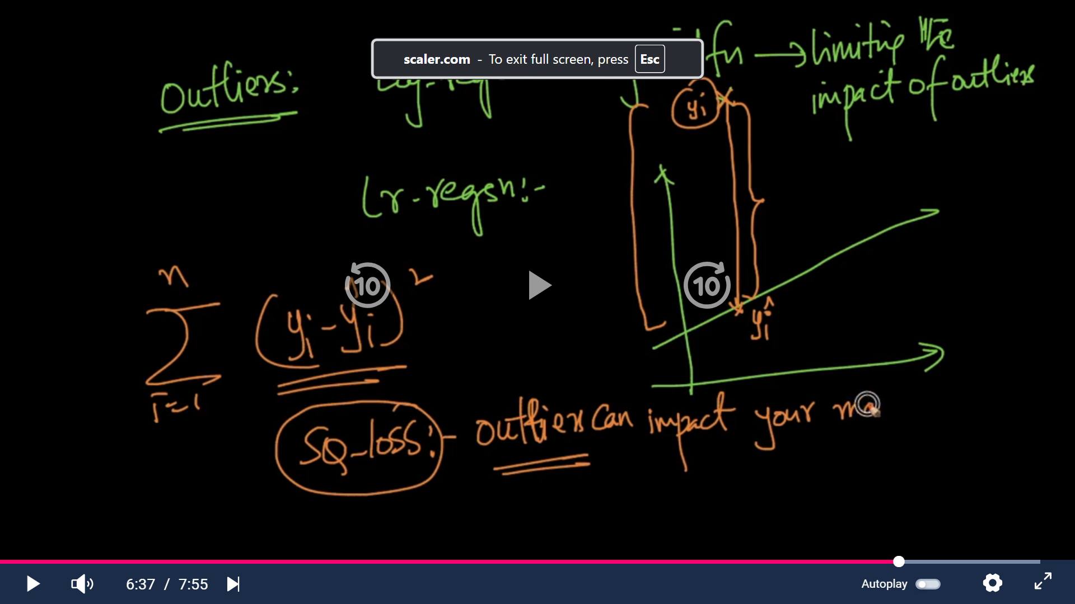
Random Forest:
Is an ensemble learning method used for both classification and regression tasks. It creates multiple decision Trees ( DT) during training and combines their predictions to make more accurate and robust predictions.
Support Vector Machines(SVM).
Draw a hyperplane in such a way that the margin distance between the hyperplane and the support vector is maximum.
Linear SVM -> For Linear data -> data which can be separated easily with 1’s and 0’s (2D data)
Non linear SVM -> For non linear data -> data which can not be separated easily with 1’s and 0’s ( we need to convert 2D data to 3D here)
Naïve Bayes:
Simple and powerful classification algorithms based on Baye’s theorem. It is widely used for task such as text classification, spam filtering, sentiment analysis and more.
Bayes theorem:
P(A/B) = P(B/A).P(A)/P(B)
P(A/B) -> Posterior prob
P(B/A) -> Likelihood prob
P(A) -> Prior prob
P(B) -> Marginal prob
Numpy:
Import numpy as np
Data_1d=np.array([1,2,3,4,5])
Data_2d=np.array([[1,2,3],[3,4,5]])
Print(data_1d.shape) ->(5,)
Print(data_2d.shape) ->(2,3)
Reshape_arr=data_2d.reshape(3,2) ->arr([[1,2],[3,4],[5,6]])
Print(data_2d.ndim)-> it will return -> 2 dimensional data
Array Indexing and slicing:
Data_2d=np.array([[1,2,3],[4,5,6]])
Print(data_2d[1,2]) ->
1st index -> points to 2nd list [4,5,6]
2nd index -> points to 3rd element in the 2nd list -> that is 6
4 has index 0, 5 has index 1 and 6 has index 2 -> that is why, it returns “6”.
Data_1d=np.array([1,2,3,4,5])
Data_1d[:3]-> returns -> [1,2,3]
Print(data_2d [ : ,1:])-> 1st one returns all the record in the data_2d array. 2nd one tells, it needs all record in the list from column 1 -> output ->[[2,3],[5,6]]
Array Operations:
A=np.array([1,2,3])
B=np.array([4,5,6])
Add=A+B
Add returns -> array([5,7,9])
Broadcasting with Scalar:
A=np.array([1,2,3])
B=10
Result =A+B
Result returns -> array([11,12,13])
Data=np.array([[1,2,3],[4,5,6]])
Total_sum=np.sum(data)
Total_sum return 21
To sum column wise -> give axis=0
Column_sum=np.sum(data, axis=0)
Column_sum returns -> array([5,7,9])
To take mean row wise -> use axis=1
Row_mean=np.mean(data, axis=1)
Row_mean return -> array([2,5]) -> [(1+2+3)/3,(4+5+6)/3]->[(6/3),(15/3)]->[2,5]
Pandas:
Series -> 1D labeled Array -> Similar to List. But we can change the indexing from 1 to ‘A’.
But it is a homogenous array. We can have only same type of datatype inside it. But in List, we can have different types of datatypes.
DataFrame is a 2D array. And also, it is a heterogenous array.
Import pandas as pd
Data=[1,2,3,4]
Series=pd.Series(Data)
Data=[1,2,3,4]
Custom_index=[‘A’,’B’,’C’,’D’]
Series=pd.Series(Data,index=Custome_index)
It will change the index from 0,1,2,3 to A,B,C,D
Series [1]-> will return 2, Series[‘B’]-> will return 2 too (So here we can access the element using default index too even though we have assigned a custom index from our end.
Result=Series+5 -> it will add 5 to each element in the above series, as I result, It will return this ->6,7,8,9

Dataframe :
Data={
‘Name’:[‘A’,’B’,’C’,’D’],
‘Age’:[10,20,30,40],
‘city’:[‘E’,’F’,’G’,’H’]
}
Df=pd.Dataframe(Data)
To print 1st row: use df.loc[0] -> it will return pandas df

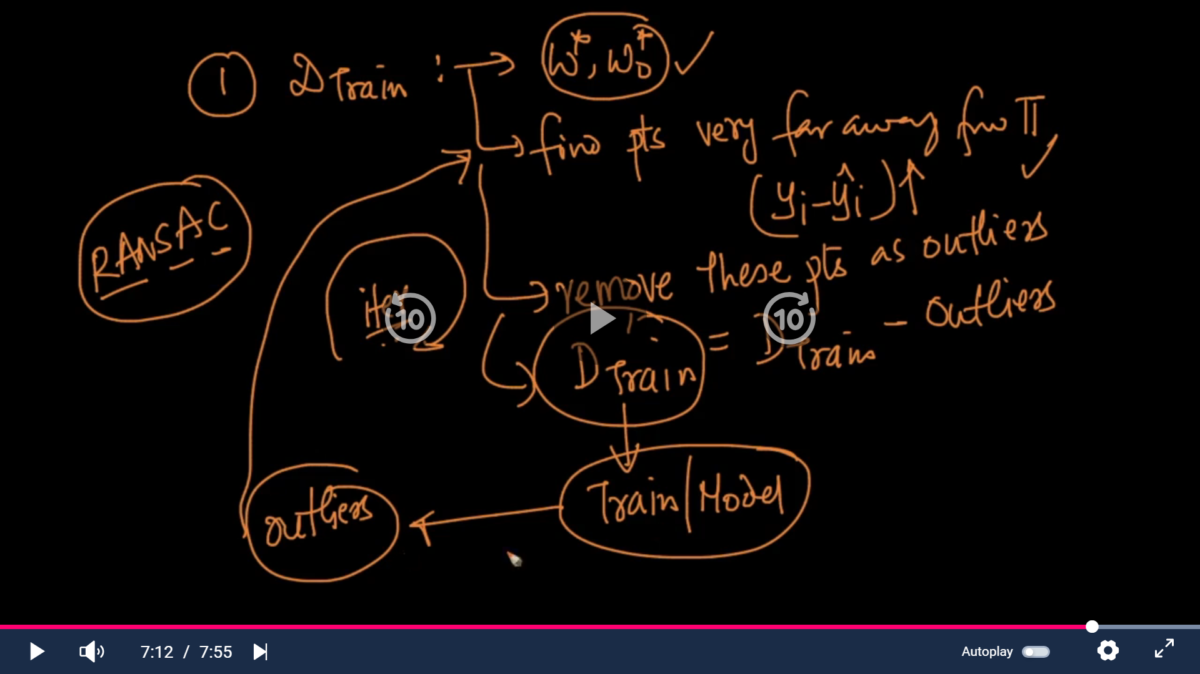
Feature Selection:
Suppose if the dataset has 1000 columns, we will not be taking all the columns to train the ML model as it needs lot of compute power.
Selecting independent feature(X) which has strong correlation with dependent features (Y) in mandatory to train the ML model (reducing features from 1000 to 100 or 200 like that)
Filter method:
Correlation method:
It can be used as a filter method to select features that have strong correlation with the target variable.
Features with a high correlation are more likely to be relevant for predicting the target.
Import pandas as pd
Data={
‘Age’:[20, 25, 35, 45],
‘Income’:[10k, 20k, 30k,40k],
‘Loan_approval’:[0,0,1,1]
}
Df=pd.Dataframe(data)
Correlation=df.corr()[‘Loan_approval’]
Correlation= Correlation.abs()
#To print the value in descending order.
Sorted_feat= Correlation.sort_values(ascending=False)
If the correlation values for a feature are > 0.6, then it is a good Correlation.
If there is a linear relationship between independent features and dependent features, then the correlation will be 1.
Independent feature value increases, dependent value also increases.
If there is a non linear relationship between independent features and dependent features, then the correlation will be -1.
Independent feature value increases, dependent value also decreases.
Select Top “K” features:
SelectKBest is a feature selection method in scikit-learn that helps you choose the top K features based on a scoring function. It’s useful when you have many features but want to keep only the most relevant ones for your model.
From sklearn.datasets import load_iris
Data=load_iris()
From sklearn.feature_selection import SelectKBest, f_classif
X,y=data.data, data.target
Df=pd.DataFrame(data.data , columns= data.feature_names)
K_best=SelectKBest(score_func=f_classif,k=2)
X_new=K_best.fit_transform(X,y)
#To get the indices of “K” best features
Selected_indices=K_best.get_support(indices=True)
Selected_features=df.columns(selected_indices)
Correlation method and selectKbest comes under FILTER METHOD.
Note: If the dataset is having huge # of columns, we can go ahead with filter method for quick processing. And also, we will filtering the features here by checking the relationship between feature and target varaiables.
✅ How it works
- You provide:
  - X (features)
  - y (target)
  - A score function (e.g., f_classif for classification, chi2 for categorical data, or f_regression for regression)
  - The number of features k you want to keep.
- It calculates a score for each feature based on its relationship with the target.
- It selects the top k features with the highest scores.

from sklearn.feature_selection import SelectKBest, f_classif
import pandas as pd

# Sample data
X = pd.DataFrame({
'Feature1': [1, 2, 3, 4],
'Feature2': [10, 20, 30, 40],
'Feature3': [100, 200, 300, 400]
})
y = [0, 1, 0, 1]

# Apply SelectKBest
selector = SelectKBest(score_func=f_classif, k=2)
X_new = selector.fit_transform(X, y)

# Get selected feature names
selected_features = X.columns[selector.get_support()]

print("Selected Features:", selected_features.tolist())

Output -> Selected Features: ['Feature2', 'Feature3']
For regression problems, we typically use SelectKBest with the scoring function f_regression, which measures the correlation between each feature and the target variable.
from sklearn.feature_selection import SelectKBest, f_regression
import pandas as pd

# Sample data
X = pd.DataFrame({
'Size': [1000, 1500, 2000, 1200],
'Bedrooms': [2, 3, 4, 2],
'Age': [10, 5, 2, 15]
})
y = [200000, 250000, 300000, 180000]

# Apply SelectKBest for regression
selector = SelectKBest(score_func=f_regression, k=2)
X_new = selector.fit_transform(X, y)

# Get selected feature names
selected_features = X.columns[selector.get_support()]

print("Selected Features:", selected_features.tolist())
print("Scores:", selector.scores_)

Output:
Selected Features: ['Size', 'Age']
Scores: [high for Size, lower for Bedrooms, moderate for Age]
Here, Size and Age are most correlated with Price, so they are selected.
Feature selection -> Wrapper method
Recursive feature elimination (RFE):
We start with all the features in the model and then remove 1 feature at a time. After each removal, we check how well the model is doing. If the model’s performance improves, we keep the feature removed. Otherwise, we put it back. We repeat this process until we find the best combination features that makes the model perform at its best.
If we want to optimize of ML model, if the dataset is having less # of feature, then we can go ahead with RFE.
Feature Encoding Technique:
Nominal Data: If there is no clear order among data -> Ex: Different variety of ice cream
Ordinal Data: When things have a natural order -> Ex:Size of t-shirt (Small, medium, large)
Binary Data -> We have only 2 choices -> Ex, Y or N / True or False
Label Encoding: -> It gives labels to each unique values in the column. For ex, assigns 0 to large, 1 to medium and 2 to small
From sklearn.preprocessing import LabelEncoder
Import pandas as pd
Data={‘size’: [‘large’,’medium’,’small’]}
Df=pd.DataFrame(Data)
Encoder=LabelEncoder()
Df[‘Encoded_size’]=Encoder.fit_transform(df[‘size’])
Print(df)
size | Encoded_size
large | 0
medium | 1
small | 2

Note: If the unique value in a column is an ordered only, then we can use label encoding. If not, we can use some other encoding for it. So, if it is an ordinal data, we can use it.
One Hot Encoding:
We can use this for nominal data. For example, there is no order between different color, different fruit and different ice-cream
Import pandas as pd
From sklearn.preprocessing import OneHotEncoder
Data={
‘fruit’:[‘apple’,’banana’,’orange’],
‘color’:[‘red’,’yellow’,’orange’]
}
Df=pd.DataFrame(Data)
Encoder=OneHotEncoder()
Encoded_color=encoder.fit_transform(df[‘color’]).toarray()
Encoded_df=pd.DataFrame(Encoded_color,columns=encoder.get_feature_names([‘color’]))
Df_encoded=pd.concat([df,Encoded_df],axis=1)
Df_encoded
 | fruits | color | color_red | color_yellow | color_orange
0 | apple | red | 1 | 0 | 0
1 | banana | yellow | 0 | 1 | 0
2 | orange | orange | 0 | 0 | 1

✅ What is get_dummies() in Pandas?
pd.get_dummies() is a Pandas function used to convert categorical variables into numerical dummy/indicator variables.
Machine learning models cannot understand text categories directly—so get_dummies() helps convert them into a numeric format.

🎯 Why do we use get_dummies()?
Because ML algorithms work with numbers.
If you have a column like:
Color
Red
Blue
Green
get_dummies() converts it into:
Color_Blue | Color_Green | Color_Red
0 | 0 | 1
1 | 0 | 0
0 | 1 | 0
This is called One-Hot Encoding.

🧪 Example
Python
import pandas as pd

df = pd.DataFrame({
'Color': ['Red', 'Blue', 'Green']
})

pd.get_dummies(df)
Show more lines
📌 Output:
Color_Blue Color_Green Color_Red
0 0 0 1
1 1 0 0
2 0 1 0

⚙️ Important Parameter: drop_first=True
This removes one dummy column to avoid multicollinearity.
Example:
Python
pd.get_dummies(df, drop_first=True)
Show more lines
Output:
Color_Green Color_Red
0 0 1
1 0 0
2 1 0

🔍 Where is get_dummies() used?
✔ Logistic Regression
✔ Linear Regression
✔ Decision Trees (optional)
✔ Random Forest
✔ Any model requiring numeric input

💡 Interview-Ready Simple Definition
get_dummies() converts categorical values into one-hot encoded numeric columns so that machine learning models can understand them. It creates a new binary column for each category.

Binary Encoding:
Import pandas as pd
From category_encoders import BinaryEncoder
Data={
‘Device’:[‘laptop,’tv’,’smartphone’],
‘portable’:[‘yes’,’no’,’yes’]
}
Df=pd.DataFrame(Data)
Encoder=BinaryEncoder(cols=[‘portable’])
Df_encoded=Encoder.fit_transform(df)
Df_encoded
 | Device | portable_0 | portable_1
0 | laptop | 0 | 1
1 | tv | 0 | 1
2 | smartphone | 1 | 0

Technique | when to use | What it Does
Label Encoding | When working with ordinal categorical data | Converts categorical data to unique numbers
One Hot Encoding | When categories have no inherent order | Converts each category to binary column
Binary Encoding | When dealing with high cardinality features(more categories) | Converts categories to binary code representation

Imbalanced dataset:
In a dataset, majority of the row labelled as “NO” (80%), only few labels as “Yes”(20%).In this case, when we train our model with this biased dataset, our model prediction will be always “NO” since it trained majorly on dataset which is having majority of the record which is related to “NO”. This is called imbalanced dataset. It leads to model overfitting.
EX:
PatientID | Age | Gender | Diagnosis
1 | 30 | M | N
2 | 12 | F | N
3 | 37 | M | N
4 | 25 | F | N
5 | 50 | F | Y

To avoid the above issue, we can go with resampling.
Under sampling:
This method is used when the quantity of data is sufficient. By keeping all the samples in the rare class and randomly selecting equal number of samples in the abundant class, a balanced new dataset can be retrieved for further modelling.
But there is a chance that some important record we may loose while down sampling. This we can do when we have millions of record and dropping few record will not cause any issue to the model performance.
Over Sampling:
Used when the quantity of the data is insufficient. It tries to balance dataset by increasing size of rare sample.
SMOTE technique is used for this.
Train Test split:
Common train test split percentage:
train | test
70 | 30
65 | 35
75 | 25
67 | 33
50 | 50

Import pandas as pd
From sklearn.model_selection import train_test_split
Data={
‘F1’:[1,2,3],
‘F2’:[4,5,6]}
Df=pd.DataFrame(Data)
x=Df[[‘F1’,’F2’]]
y=Df[[‘target’]]
X_train,X_test,y_train,y_test=train_test_split(x,y,test_size=0.25,randome_state=25)
N.B.: random_state parameter By setting a fixed value for random_state, you can ensure that the random split of the data will be the same each time you run the code. This is useful for reproducibility and ensuring that your results are consistent.
If you do not set the random_state parameter, the split will be different each time you run the code, which can make it difficult to reproduce your results or compare them to previous results.
The value you should use for random_state is up to you. Any integer value can be used, as long as you use the same value consistently. Some people like to use special numbers such as 42 or 1234, but this is a matter of personal preference. The important thing is that you use the same value consistently if you need to reproduce your results.
Why use stratify=y?
If your target is binary or multiclass classification, and your classes are imbalanced (unequal proportions), a random split without stratification can cause one set (train or test) to have a very different ratio of classes than the other.
This can lead to biased training or misleading evaluation results, because the test set might be unrepresentative of the true population.
Stratification ensures that each split keeps the same approximate percentage of samples for each class as in the original dataset.
If your classes are already perfectly balanced or you’re doing regression, stratification is less critical, but for classification tasks—especially imbalanced ones—it’s highly recommended.
v1 parameters
Parameter | Value | Why It’s Good
learning_rate=0.01 | Very low | Slows down the learning to allow the model to learn patterns gradually. Prevents overfitting but requires more trees (n_estimators). This is often used with early stopping.
max_depth=4 | Shallow trees | Controls the complexity of each tree. A lower depth helps generalization by avoiding deep, overfit trees that memorize training data. Typical range: 3–6.
min_child_weight=1 | Default (low) | Minimum sum of instance weights (or sample count) needed in a child. Low values allow the model to learn specific patterns. If overfitting, consider increasing to 3–5.
subsample=0.8 | Moderate | Randomly samples 80% of training data per tree. Adds variance (like bagging) and prevents overfitting. Try 0.6–0.9 for experimentation.
colsample_bytree=0.8 | Moderate | Similar to subsample, but operates on features. Reduces reliance on specific features and increases generalization. Works well with subsample.
gamma=0 | No pruning | Controls whether a split happens based on loss reduction. 0 means split if it improves loss, even slightly. If you want to regularize more aggressively, increase this (e.g., 1–5).
reg_alpha=0 | No L1 regularization | L1 adds sparsity by shrinking feature weights to 0. You can set this > 0 (e.g., 0.1–1) if you want to penalize complexity more.
reg_lambda=1 | Default L2 regularization | L2 discourages large weights. This is always helpful in controlling model complexity. You can try increasing it if you're still overfitting.
n_estimators=1000 | High | Since your learning_rate is very low (0.01), you need many trees. With early stopping, the model will stop when performance plateaus.
objective='binary:logistic' | Correct for binary targets | This is the proper loss function for binary classification. It outputs probabilities and supports predict_proba.
eval_metric='logloss' | Probabilistic metric | Measures how close the predicted probabilities are to actual labels. Good if you care about model calibration. You can also try 'auc' if ranking is more important.
n_jobs=-1 | All CPU cores | Speeds up training by parallelizing across all CPU threads.
random_state=42 | For reproducibility | Ensures that train/test splits and model training are deterministic. Critical for debugging, reproducibility, and consistent Optuna runs.

Change | Why
'eval_metric': 'auc' | AUC is threshold-independent and often better for performance monitoring in binary tasks.
learning_rate: 0.02 | Still slow, but trains faster than 0.01 with similar generalization.
min_child_weight: 3 | Avoids splits that are too specific and potentially noisy.
gamma: 1 | Adds pruning — avoids unnecessary splits that don’t improve model significantly.
reg_alpha: 0.1 | Adds sparsity and reduces model complexity.
verbosity: 1 | Allows useful feedback during training (e.g., AUC at each iteration).

params_v2 = {
'objective': 'binary:logistic', # Binary classification task
'eval_metric': 'auc', # Better than logloss for imbalanced datasets or ranking tasks
'learning_rate': 0.02, # Slower learning to reduce overfitting
'max_depth': 4, # Shallow trees generalize better
'min_child_weight': 3, # Prevents learning from very small, noisy splits
'subsample': 0.8, # Adds randomness to rows, reduces overfitting
'colsample_bytree': 0.8, # Adds randomness to columns/features
'gamma': 1, # Minimum gain required to make a further split (pruning)
'reg_alpha': 0.1, # L1 regularization (feature sparsity)
'reg_lambda': 1, # L2 regularization (weight shrinkage)
'n_estimators': 1000, # High number of trees (but use early stopping)
'n_jobs': -1, # Use all cores
'verbosity': 1 # Show evaluation logs
}
This code is used to evaluate a binary classification model (likely an XGBoost classifier, xgb_clf) using a custom probability threshold instead of the default 0.5.
1. Set the Best Threshold
best_thresh = 0.2560
- This is a manually or programmatically selected threshold for converting predicted probabilities into binary class labels.
- Instead of using the default 0.5, the model will classify a sample as positive (1) if the predicted probability is ≥ 0.2560.

2. Get Predicted Probabilities
y_probs = xgb_clf.predict_proba(X_test)[:, 1]
- predict_proba returns probabilities for both classes: [prob_class_0, prob_class_1].
- [:, 1] selects the probability of the positive class (class 1) for each sample in X_test.
3. Apply Threshold to Get Binary Predictions
y_pred_best = (y_probs >= best_thresh).astype(int)
- Converts probabilities into binary predictions:
  - If y_prob ≥ 0.2560, predict 1
  - Else, predict 0
- .astype(int) converts the boolean array to integers (True → 1, False → 0)
4. Evaluate the Model
from sklearn.metrics import accuracy_score, precision_score, recall_score, f1_score, confusion_matrix, classification_report
- Importing evaluation metrics from sklearn.
5. Compute Metrics
accuracy = accuracy_score(y_test, y_pred_best)
precision = precision_score(y_test, y_pred_best)
recall = recall_score(y_test, y_pred_best)
f1 = f1_score(y_test, y_pred_best)
cm = confusion_matrix(y_test, y_pred_best)
report = classification_report(y_test, y_pred_best, digits=4)
- Accuracy: Overall correctness of predictions.
- Precision: Of all predicted positives, how many were actually positive.
- Recall: Of all actual positives, how many were correctly predicted.
- F1 Score: Harmonic mean of precision and recall.
- Confusion Matrix: Shows TP, FP, FN, TN.
- Classification Report: Includes precision, recall, F1-score, and support for each class.
6. Print the Results
print(f"Accuracy at threshold {best_thresh:.4f}: {accuracy:.4f}")
print(f"Precision at threshold {best_thresh:.4f}: {precision:.4f}")
print(f"Recall at threshold {best_thresh:.4f}: {recall:.4f}")
print(f"F1 Score at threshold {best_thresh:.4f}: {f1:.4f}")
print("Confusion Matrix:")
print(cm)
print("\nClassification Report:\n", report)
Why Use a Custom Threshold?
- The default threshold of 0.5 may not be optimal, especially in imbalanced datasets.
- Lowering the threshold (like 0.2560) can increase recall (catch more positives) at the cost of precision (more false positives).
- This is useful in domains like fraud detection, medical diagnosis, etc., where missing a positive case is more costly than a false alarm.
What is DMatrix in XGBoost?
DMatrix is a data structure used internally by XGBoost to optimize performance and memory usage. It’s more efficient than using regular NumPy arrays or Pandas DataFrames, especially for large datasets.
Key Features of DMatrix:
- Stores data in a compressed format.
- Handles missing values efficiently.
- Supports weights for individual data points.
- Enables faster training and prediction.
Feature Scaling:
Feature scaling is a preprocessing technique in machine learning used to standardize or normalize the range of independent variables or features of data. The goal of feature scaling is to ensure that all features have similar scales or magnitudes.
1)min max scaling (Normalization):
This method scales the features to a specific range typically between 0 and 1.
Formula=X-Xmin/(Xmax-Xmin)
Ex:
Min_math=30
Max_math=100
Your_score_math=80
Scaled math score=(Your_score_math-Min_math)/(Max_math-Min_math)
Scaled math score=(80-30)/(100-30) -> 50/70=0.7142
Z_score scaling or Standardization:
Standardization transforms features to have a mean of 0 and standard deviation of 1.
Xstd=X-mean/ standard deviation
Ex:
The avg mean score is 60
The standard deviation is 15
For your game, score of 75 , it is 15 points above the average score
Z_score=(your_score-mean_score)/std_dev->(75-60)/15->15/15->1
Classification Evaluation metrics:
These performance metrics help us to understand how well our model has performed on the given data.
Accuracy
Recall
Precision
F1 score
Confusion metrics
Accuracy:
Imagine you have build a spam email filter, a program that predicts whether an incoming email is spam or not. You feed it 100 emails to test the performance.
Your spam email filter correctly identifies 80 emails as not spam.
It correctly identifies 15 emails as spam
However, it makes mistakes and classifies 5 non-spam email as spam
Accuracy= (Number of correct prediction)/ (Total number of prediction)
Accuracy= (80+15)/100->95%
It means that our model is 95% accurate during the prediction
Accuracy = மொத்த கணிப்புகளில் எத்தனை சரியாக இருக்கின்றன என்பதை காட்டும் விகிதம்.
உதாரணம்:
நீங்கள் 100 கேஸ்களை கணிப்பிட்டீர்கள். அதில் 90 சரியாக இருந்தால்:
Accuracy=90/100=90%
✅ When is Accuracy Useful?
- When the classes are balanced (i.e., roughly equal number of samples in each class).
- Class balance இருக்கும்போது (உதா: Positive & Negative records சமமாக இருக்கும்போது).
- False positives மற்றும் False negatives முக்கியமல்லாத application-ல்.
When Accuracy Can Be Misleading
- In imbalanced datasets, accuracy can be high even if the model is performing poorly. For example, in a dataset with 95% of one class, a model that always predicts that class will have 95% accuracy but zero usefulness.
- ஒரு dataset-ல் 95% negative records இருந்தால், எல்லா records-ஐ negative என்று predict செய்தாலும் accuracy 95% ஆகும். ஆனால் இது பயனற்றது.
Better Alternatives in Some Cases
- Precision, Recall, F1 Score – for imbalanced datasets.
- ROC-AUC – for evaluating classification performance across thresholds.
- Confusion Matrix – for a detailed breakdown of prediction outcomes.
மாற்று அளவீடுகள்:
- Precision – சரியாக positive predict செய்த விகிதம்.

🔍 Precision (துல்லியம்)
- என்பது, மாடல் positive என்று predict செய்தவற்றில் எத்தனை உண்மையில் positive என்பதை காட்டும் அளவீடு.

எளிய தமிழ் விளக்கம்:
மாடல் "positive" என்று சொன்ன 100 பேரில் உண்மையில் 80 பேர் positive இருந்தால், precision = 80%.
Precision=TruePositives/TruePositives+FalsePositives
- Recall – மொத்த positive-ல் எத்தனை சரியாக கண்டுபிடித்தது.
🔍 Recall (நினைவு திறன்)
- Recall என்பது, மொத்த உண்மையான positive-ல் எத்தனை மாடல் கண்டுபிடித்தது என்பதை காட்டும் அளவீடு.
Recall= TruePositives /TruePositives+FalseNegatives
எளிய தமிழ் விளக்கம்:
மொத்தம் 100 பேர் positive இருந்தால், மாடல் அதில் 70 பேரை மட்டும் கண்டுபிடித்தால், recall = 70%.
📊 ஒப்பீடு:
அளவீடு | என்ன சொல்கிறது? | எப்போது முக்கியம்?
Precision | Predict செய்த positive-ல் எத்தனை உண்மையான positive | False positive தவிர்க்க வேண்டிய போது (உதா: spam filter)
Recall | மொத்த positive-ல் எத்தனை கண்டுபிடிக்கப்பட்டது | False negative தவிர்க்க வேண்டிய போது (உதா: cancer detection)

- F1 Score – Precision & Recall-ஐ balance செய்யும் அளவீடு.
- F1 Score=2×( Precision x Recall )/(Precision+Recall)
- Confusion Matrix – TP, TN, FP, FN breakdow
Important terms:
True positive (TP) is an outcome where the model correctly predicts the positive class.
True negative (TN) is an outcome where the model correctly predicts the negative class
Ex: Let’s consider that you have a magical detector when can detect who is having superpower in human or not.
When you use that magic detector on human who is having superpower, it tells that he is having superpower. This is called TP
When you use the same magic detector another human who is not having superpower, it tells that he is not having superpower. This is called TN.
False positive (FP): is an outcome where the model incorrectly predicts the positive class
False negative (FN): is an outcome where the model incorrectly predicts the negative class
When you use that magic detector on human who is not having superpower, it tells that he is having superpower. This is called FP
When you use the same magic detector another human who is having superpower, it tells that he is not having superpower. This is called FN.
🔍 TP, TN, FP, FN என்றால் என்ன?
✅ True Positive (TP) – உண்மையான நேர்மறை
மாடல் ஒரு data point-ஐ "Positive" என்று correctly predict செய்தால்.
- உதாரணம்: ஒரு நோயாளிக்கு நோய் உள்ளது என்றும் மாடல் சரியாக கண்டறிந்தது.
✅ True Negative (TN) – உண்மையான எதிர்மறை
மாடல் ஒரு data point-ஐ "Negative" என்று correctly predict செய்தால்.
- உதாரணம்: ஒரு நபருக்கு நோய் இல்லை என்றும் மாடல் சரியாக கண்டறிந்தது.
❌ False Positive (FP) – தவறான நேர்மறை
மாடல் "Positive" என்று predict செய்தது, ஆனால் உண்மையில் அது "Negative".
- உதாரணம்: ஒரு நபருக்கு நோய் இல்லை, ஆனால் மாடல் நோய் உள்ளது என்று தவறாக கூறியது.
❌ False Negative (FN) – தவறான எதிர்மறை
மாடல் "Negative" என்று predict செய்தது, ஆனால் உண்மையில் அது "Positive".
- உதாரணம்: ஒரு நபருக்கு நோய் உள்ளது, ஆனால் மாடல் நோய் இல்லை என்று தவறாக கூறியது.

📊 இவை எதற்காக பயன்படுகின்றன?
இவை மூலம் precision, recall, accuracy போன்ற metrics-ஐ கணக்கிடலாம்:
- Accuracy = (TP+TN)/(TP+TN+FP+FN
- Precision = TP/(TP+FP)
- Recall = TP/(TP+FN)
Regression metrics:
Mean Absolute Error (MAE)
Mean Squared Error (MSE)
R-Squared (Coefficient for determination)
Mean Absolute Error (MAE):
Metric used to measure the average absolute difference between predicted and actual values in a dataset.
Mean Absolute Error = மாடல் predict செய்த value மற்றும் உண்மையான value இடையிலான தவறுகளின் சராசரி.
MAE=1/n ​∑ ∣yi​−y^​i​∣ (i= 1 to n)
- yi​ = உண்மையான மதிப்பு (actual value)
- y^i ​ = மாடல் predict செய்த மதிப்பு
- n = மொத்த data points
🎯 எளிய உதாரணம்:
உண்மையான மதிப்புகள்: [100, 200, 300]
Predict செய்த மதிப்புகள்: [110, 190, 310]
Error = |100−110| + |200−190| + |300−310| = 10 + 10 + 10 = 30
MAE = 30 / 3 = 10
அதாவது, மாடல் ஒவ்வொரு prediction-க்கும் சராசரியாக(average ah) 10 units தவறாக predict செய்கிறது.

✅ MAE-ன் சிறப்புகள்:
- எளிதாக புரிந்துகொள்ளலாம்
- Outliers-ஐ அதிகம் பாதிக்காது (compared to squared error)

⚠️ எப்போது MAE சரியானது?
- நீங்கள் average error-ஐ நேரடியாக பார்க்க விரும்பும்போது.
- Linear scale-ல் error-ஐ மதிப்பீடு செய்யும்போது.

MAE should be always low.
Mean Squared Error (MSE)
Mean Squared Error (MSE) என்பது regression மாடல்களில் பயன்படுத்தப்படும் ஒரு முக்கியமான error metric ஆகும். இது மாடல் predict செய்த மதிப்புகள் மற்றும் உண்மையான மதிப்புகளுக்கு இடையிலான தவறுகளின் சதுரத்தின் சராசரி.
தமிழில் எளிய விளக்கம்:
Mean Squared Error = மாடல் predict செய்த மதிப்பும் உண்மையான மதிப்பும் இடையிலான தவறுகளை சதுரமாக்கி, அதன் சராசரி.
சூத்திரம்:
MSE=1/n∑ (yi−y^i)2 (i= 1 to n)
இங்கு:
- yi​ = உண்மையான மதிப்பு
- y^i = மாடல் predict செய்த மதிப்பு
- n= மொத்த data points

🎯 எளிய உதாரணம்:
- உண்மையான மதிப்புகள்: [100, 200, 300]
Predict செய்த மதிப்புகள்: [110, 190, 310]
- Error = (100−110)² + (200−190)² + (300−310)² = 100 + 100 + 100 = 300
MSE = 300 / 3 = 100
MSE-ன் சிறப்புகள்:
- பெரிய தவறுகளை அதிகமாக penalize செய்யும் (சதுரம் என்பதால்).
- Model optimization-க்கு math-ல் எளிதாக handle செய்யலாம்.
எப்போது MSE சரியானது?
- நீங்கள் பெரிய தவறுகளை கண்டறிந்து குறைக்க விரும்பும்போது.
- Outliers-ஐ identify செய்ய வேண்டிய regression problems-ல்.
MSE should be low.
R-Squared (Coefficient of determination):
R-squared, also known as the coefficient of determination, is a statistical measure used to evaluate how well a regression model explains the variability of the dependent variable.
Definition
R-squared represents the proportion of the variance in the dependent variable that is predictable from the independent variable(s).
📐 Formula
For a simple linear regression:
R2=1−( SSres​​/ SStot​)
இங்கு:
- SSres​: மீதமுள்ள சதுரத் தொகை (Residual Sum of Squares)
- SStot​: மொத்த சதுரத் தொகை (Total Sum of Squares)
📊 Interpretation
- R2=1: Perfect fit — the model explains all the variability (மாதிரி 100% சரியாக பொருந்துகிறது)
- R2=0: The model explains none of the variability (மாதிரி எந்த விளக்கத்தையும் தரவில்லை.)
- Between 0 and 1: Partial explanation of the variance (மாதிரி ஒரு அளவுக்கு விளக்குகிறது.)
- Can be negative (in some models): Indicates the model performs worse than a horizontal line (mean of the data) -> மாதிரி சராசரி மதிப்பை விட மோசமாக செயல்படுகிறது.
✅ Use Cases
- Evaluating linear regression models.
- Comparing the fit of different models (though adjusted R² is better for multiple predictors).
- Understanding how well predictors explain the outcome.
Total Variation (SS Tot):
This is like all the possible difference between your actual score and average score you usually get. It’s how much your score can change naturally.
Unexplained Variation (SS Res):
This is like the difference between what your model predicts and what you actually get in your exams. It’s how much your model gets wrong.
R square value should be high for good model.
Unsupervised algorithm:
- Clustering
- Dimensionality reduction
Clustering:
It’s a technique used to group similar data points together based on certain features or characteristics they share.
Hierarchical Clustering:
Another unsupervised ML algorithm, which is used to group the unlabelled datasets into a cluster.
Dimensionality reduction:
It is a technique used in data analysis and machine learning to simplify large and complex datasets by reducing the number of features (or dimensions) while retaining the most important information.
The curse of dimensionality and overfitting.
There is a chance of overfitting when the model is having high dimensional data (like more features or columns)
To avoid High dimensional data, we can follow 2 methods.
  - Feature selection -> we can check correlation between features and choose features (independent variable) which plays a major role in predicting the dependent variable (actuals or labels or target)
  - PCA (Principal component Analysis):
It is a statistical process that converts the observation of correlated features into set of linearly uncorrelated features with the help of orthogonal transformation. These new transformed features are called the principal components.
Outliers:
Outliers are datapoints that significantly differs from the majority of the data in the dataset. These data points are unusual or exceptional in some way and can have a substantial impact on data analysis and statistical modelling.
Computer Vision:
CV is a field of AI that uses ML and neural networks to teach computers and systems to derive meaningful information from digital images, videos and other visual inputs—and to make recommendations or take actions when they see defects or issue.
Hugging face -> Allows AI developers to access the pretrained models easily via API. Additionally, the transformers library provides an efficient way to create machine learning pipelines.
With Hugging face -> user can share ML models, use pre-trained models, fine tune ML models, Host demos and evaluate ML models.
Langchain:
A valuable tool for developing AI powered Apps, is a open-source orchestration environment. Available in python and java script.

Linear regression is a supervised learning algorithm used for: Regression tasks
The goal of linear regression is to: Minimize the sum of squared residuals
In linear regression, the relationship between the dependent variable and independent variable(s) is assumed to be: Linear
The coefficient of determination, also known as R-squared, represents: The proportion of the variance in the dependent variable explained by the independent variable(s)
Q1. Explain ML Data preparation and EDA steps in detail. What are major steps in preprocessing
ML data preparation involves cleaning, transforming, and organizing data for analysis. EDA involves exploring and visualizing data to understand its characteristics.
- Data cleaning: removing missing values, handling outliers, and dealing with duplicates
- Data transformation: encoding categorical variables, scaling numerical features, and creating new features
- Data organization: splitting data into training and testing sets, and handling imbalanced classes
- Exploratory Data Analysis (EDA): visualizing data using histograms, scatter plots, and correlation matrices
- Identifying patterns and relationships in the data to inform modeling decisions
Q2:What is Data Analysis?
Data analysis is the process of inspecting, cleaning, transforming, and modeling data to discover useful information.
- It involves collecting and organizing data
- It includes statistical analysis and visualization
- It helps in making informed decisions
- Examples include market research, financial analysis, and scientific research

Q3: SQL Queries using Joins and sub-queries

- Joins are used to combine rows from different tables based on a related column
- Sub-queries are queries nested within another query
- Joins and sub-queries can be used together to retrieve specific data from multiple tables

Q4: What is CLT theorem and what are its uses
Central Limit theorem (CLT)
- Central Limit Theorem (CLT) is a fundamental concept in statistics that states that the distribution of sample means approaches a normal distribution as the sample size increases.
- For example, if you take multiple samples of the same size from a population and calculate the mean of each sample, the distribution of those sample means will be approximately normal according to the CLT.
Scenario:
Imagine a telecom company wants to encourage customers to switch to a new, better data plan. They decide to run a special promotion.

Definitions in Simple Terms:
- Lift: How much better the promotion worked compared to doing nothing.
- Capture Rate: How many of the people they tried to reach with the promotion actually switched to the new plan.

Example:
- Initial Situation:
  - Without Promotion: Normally, if they don’t do anything, 2% of customers would switch to the new data plan.
- Running the Promotion:
  - The company targets 1,000 customers with a special offer.
  - Out of these 1,000 customers, 200 switch to the new data plan.
- Calculate Lift:
  - Response Rate with Promotion: 200 out of 1,000 customers switched, so the response rate is 20%.
  - Baseline Response Rate: Without promotion, only 2% of customers would switch.
Lift Calculation:
Lift=Response Rate with Promotion/Baseline Response Rate
Lift=(20%)/(2%)=10
What It Means: The promotion made switching 10 times more likely compared to doing nothing. It’s very effective!
- Calculate Capture Rate:
  - Capture Rate Calculation:
Capture Rate=Total Number of Targeted Customers /Number of Switchers​ Capture Rate=1000/200 => 20%
Capture rate: 20% of the customers who were offered the promotion switched to the new data plan.

Summary in Simple Terms:
- Lift tells you how much better the promotion was compared to not doing anything. In this case, it was 10 times better.
- Capture Rate tells you how many of the people they targeted actually switched to the new plan. Here, it was 20%.
These metrics help the telecom company understand how successful their promotion was and whether it’s worth doing more campaigns like this in the future.
What are the different pipeline in azure devops?
Build Pipeline:
These pipeline job copy code from github repository and build the project based on instructions provided in the yaml file.
Typically, we use this to publish artifacts of Project
Release pipeline:
Used to deploy the build artifacts into agent machine
Create Release:
Helps us to build end to end pipeline(Connecting Build and release pipeline) for CI/CD implementation.
Create Build Pipeline:
Click on create pipeline -> where is the code-> click on Git->select repository
Configure pipeline -> choose Maven -> automatically 1 yaml file will get created -> azure_pipeline.yml -> it will be responsible to build your project -> Save & run
Pyspark related questions:
Hadoop ecosystem:
HDFS -> Hadoop distributed file system
YARN -> OS
Map Reduce -> mapping and reducing data
Spark ecosystem:
Spark build on Hadoop ecosystem.
Spark is just on alternate of map reduce. It also used HDFS and YARN
Spark Architecture:
Spark context or driver node -> Cluster manager->Multiple worker node to process the data distributed
Cluster manager manages worker node
Important libraries of spark -> Spark SQL, Spark streaming, Spark Mllib and Spark Graphx
RDD:
Resilient Distributed System
Internally spark distributes the data in RDD, to different nodes across the cluster.
Df=spark.read.option(“header”,True).csv(‘text.csv’)
RDD is created using spark context
DF is created using spark session
To rename a column in DF:
Df=df.withColumnRenamed(“gender”,”sex”).withColumnRenamed(“roll”,”roll_no”)
To give a alias name for a column in DF:
Df.select(col(“name”).alias(“full_name”))
To filter record from DF:
Df.filter(df.course==”IT”).show() -> equalant to this ->df.filter(col(“course”)==”IT”).show()
Df.filter((df.course==”IT”)&(df.marks>50)).show()
Filter using multiple values:
Courses=[“IT”,”CSE”,”MECH”]
Df.filter(df.course.isin(Courses)).show()
Df.filter(df.course.startsWith(“I”))
Df.filter(df.course.endsWith(“I”))

From pyspark.sql.functions import col
Df=df.withColumn(“roll_str”,col(“roll”.cast(“String”))
Df2=df.withColumn(“mark_2”,col(“marks”)+10)
From pyspark.sql.funcstions import lit
Lit is used to assign hard coded values for a column
Df3=df.withColumn(“Country”,lit(“India”))
Df4=df.withColumn(“mark”,col(“mark”)-10).withColumn(“mark_3”,col(“mark”)+20)

Df.filer(df.coures==”IT”).count() -> count prints count of number of rows present in that df
Df.select(“genede”,”age”).distinct().count() -> prints the count of unique data present in the df
Sort, Orderby: -> Both does same job. Column must be in integer to sort it based on it
From pyspark.sql import Sparksession
From pyspark.sql.functions import col, lit
Spark=Sparksession.builder.appName(“spark Df”).getOrCreate()
Df=spark.read.options(header=’True’,inferSchema=’True’).csv(‘/File/text.csv’)
header=’True’ -> This tells to consider 1st rows as
Df.sort(“marks”).show() -> it sorts record in ascending order based on marks.
Df.sort(df.marks.asc(),df.age.desc()).show()
Df.orderBy(df.marks.asc(),df.age.desc()).show()
GroupBy -> To group data based on particular columns and do the aggregation for some columns
Df.groupBy(“gender”). sum(“marks”).show()
Df.groupBy(“gender”). count().show()
Df.groupBy(“gender”). max(“marks”).show()
Df.groupBy(“gender”). min(“marks”).show()
To find out average marks of each age group
Df.groupBy(“age”). avg(“marks”).show()
From pyspark.sql.functions import sum,avg,max,min,mean,count
Df.groupBy(“course”).agg(count(‘*’)).show() -> * means static-> it means consider any column
Df.groupBy(“course”).agg(count(‘*’),sum(“marks”),max(“marks”),min(“marks”),avg(“marks”)).show()
Df.groupBy(“course”).agg(count(‘*’).alias(“total_enroll”),sum(“marks”).alias(“total_mark”),max(“marks”).alias(“max_mark”),min(“marks”).alias(“min_mark”),avg(“marks”).alias(“avg_mark”).show()
NLP:
Step1 :To create a new virtual environment in anaconda prompt:
Conda create –name nlp_course_env python=3.11
Note: Here we are creating this virtual env: nlp_course_env and installing python on it.
Step2:
Once env created, we need to activate it.
Conda activate nlp_course_env
Virtual environments are a great way to manage different packages for different projects. Creating a virtual environment for this section of the course allows you to ensure you can use the correct packages to follow along, without affecting any other packages you already have installed.
conda create --name nlp_course_env python=3.11
conda activate nlp_course_env
Install necessary libarary
pip install nltk==3.9.1 pandas==2.2.3 matplotlib==3.10.0 spacy==3.8.3 textblob==0.18.0.post0 vaderSentiment==3.3.2 transformers==4.47.1 scikit-learn==1.6.0 gensim==4.3.3 seaborn==0.13.2 torch==2.5.1 ipywidgets==8.1.5
Download a language model: en_core_web_sm from Spacy. It is used for various NLP task
python -m spacy download en_core_web_sm
Register Virtual env : nlp_course_env in ipykeranl to use the installed libraries there.
python -m ipykernel install --user --name=nlp_course_env
Next go to Anaconda Navigator app -> Select current virtual env: nlp_course_env there -> then install jupyter noteebook
pip install ipykernel jupyterlab notebook
Setting up the environment and exploring the packages (text article)
1. Creating new Python evironment.
A virtual environment is like a separate workspace for Python. It has its own Python version and its own set of installed packages. This way:
- You can install the exact versions needed for the course.
- You won’t break any other Python projects on your computer.
We’ll create and manage this environment with conda - a package and environment manager.
Open the Anaconda/Miniconda Prompt (Windows) or Terminal (macOS/Linux) and execute the commands below:
conda create --name nlp_course_env python=3.11
conda activate nlp_course_env
When activated, you’ll see (nlp_course_env) appear before the command line.
2. Installing the relevant packages.
To install the required packages into the new environment, we'll use pip - Python’s built-in package installer. Think of conda as setting up the room (environment), and pip as bringing in the furniture (the libraries).
We use pip here because some packages are easiest to install from PyPI.
In Anaconda Prompt or Terminal, execute:
pip install "numpy<2.0" nltk==3.9.1 pandas==2.2.3 matplotlib==3.10.0 spacy==3.8.3 textblob==0.18.0.post0 vaderSentiment==3.3.2 transformers==4.47.1 scikit-learn==1.6.0 gensim==4.3.3 seaborn==0.13.2 torch==2.5.1 ipywidgets==8.1.5 chardet ipykernel jupyterlab notebook

Next, download the spaCy language model:
python -m spacy download en_core_web_sm
And register the new environment as a Jupyter kernel:
python -m ipykernel install --user --name=nlp_course_env

Then, open Anaconda Navigator and remember to set the environment to "nlp_course_env". Launch Jupyter Notebok and check the kernel is also set to "nlp_course_env".

********************************************************************************************************
3. Explaining the packages.
Let's now breakdown what each library is used for:
- nltk (3.9.1) – The Natural Language Toolkit, one of the oldest and most widely used NLP libraries. It includes tools for breaking text into words or sentences (tokenizers), simplifying words to their base form (stemmers, lemmatizers), and accessing large text collections and linguistic datasets. Great for learning and experimenting with NLP basics.
- pandas (2.2.3) – Provides the DataFrame structure, which makes it easy to load, clean, and organize data in rows and columns (similar to Excel, but much more powerful). You’ll use it to manipulate text datasets and combine them with other information.
- matplotlib (3.10.0) – The fundamental Python plotting library. It lets you create line charts, bar graphs, scatter plots, and more. Think of it as the "drawing canvas" for your data visualizations.
- seaborn (0.13.2) – Built on top of matplotlib, but with easier functions and beautiful default styles. It’s especially good for statistical plots, like showing correlations between variables or distributions of data.
- scikit-learn (1.6.0) – A general-purpose machine learning toolkit. It provides algorithms for classification, regression, clustering, feature extraction, and model evaluation. It’s often used for building traditional ML models before moving on to deep learning.
- spaCy (3.8.3) – A modern NLP library designed for speed and production use. It handles advanced tasks like part-of-speech tagging (identifying nouns/verbs), named entity recognition (detecting people, places, organizations), and syntactic parsing. It’s faster and more practical than NLTK for large-scale projects.
- TextBlob (0.18.0.post0) – A beginner-friendly NLP library that wraps around NLTK and other tools. It makes common tasks like sentiment analysis, phrase extraction, and translation very simple with just a few lines of code.
- VADER Sentiment (3.3.2) – A lightweight, rule-based tool for sentiment analysis, tuned for short, casual texts like tweets, reviews, and comments. It understands things like exclamation marks, capitalization, and even emoji sentiment.
- gensim (4.3.3) – A library for topic modeling and working with word embeddings. It’s known for algorithms like Word2Vec (which learns word meanings from context) and LDA (Latent Dirichlet Allocation) for discovering hidden topics in large text collections.
- transformers (4.47.1) – From Hugging Face, this is the go-to library for using state-of-the-art NLP models like BERT, GPT, and other large language models. It makes it easy to load pretrained models for tasks like classification, text generation, and translation.
- PyTorch (torch 2.5.1) – A deep learning framework that powers libraries like transformers. It’s used to build and train custom neural networks for NLP and beyond. Many cutting-edge AI models are implemented in PyTorch.
- ipywidgets (8.1.5) – Provides interactive controls (like sliders, dropdowns, and buttons) inside Jupyter notebooks. These let you build small UIs that make experiments more visual and hands-on.
- NumPy <(2.0.0) – The foundational library for numerical computing in Python. It introduces the powerful ndarray object, which lets you store and process large arrays and matrices of numbers efficiently. NumPy is behind almost every data science or machine learning library — it provides the fast, vectorized math operations that make Python suitable for heavy computations. You’ll use it for tasks like matrix operations, statistical calculations, and data transformations that feed into models or visualizations.
1. The "pd.Series" Object
A Series is a one-dimensional labeled array — like a single column in a spreadsheet.
Here’s how to create one:
- import pandas as pd
- numbers = pd.Series([10, 20, 30, 40])
- print(numbers)
Output:
- 0 10
- 1 20
- 2 30
- 3 40
- dtype: int64
Let’s unpack that:
- Each value (10, 20, 30, 40) has a label, called an index (0, 1, 2, 3 by default).
- The “dtype” at the bottom shows the data type of the elements (in this case, integers).
You can think of a Series as a column of data with labels.

2. The "pd.DataFrame" Object
A DataFrame is a two-dimensional table — like a full spreadsheet with rows and columns.
Here’s an example:
- import pandas as pd
- data = {
- "Name": ["Alice", "Bob", "Charlie"],
- "Age": [25, 30, 35],
- "City": ["London", "Paris", "Berlin"]
- }
- df = pd.DataFrame(data)
- print(df)
Output:
- Name Age City
- 0 Alice 25 London
- 1 Bob 30 Paris
- 2 Charlie 35 Berlin
Explanation:
- Each key in the dictionary ("Name", "Age", "City") becomes a column.
- Each list inside the dictionary becomes the data for that column.
- Pandas automatically adds an index column on the left (0, 1, 2).
You can think of a DataFrame as a collection of Series that share the same index.
Text preprocessing with pandas and NLTK
1. Removing Stopwords.
- data['review_no_stopwords'] = data['review_lowercase'].apply(lambda x: ' '.join([word for word \
- in x.split() if word \
- not in (en_stopwords)]))
At first, it might look intimidating — but this codeblock is simply doing several small, logical steps one after another. It’s written in one line to be compact, but let’s break it down and explain why each part is there and what it does.
(Note: In Python, a backslash at the end of a line means: “This line of code continues on the next line.” If your line of code is too long, or you want to break it for readability, you can put a \ at the end — and Python will treat the next line as if it’s part of the same command.)
Step 1. Creating a new column
data['review_no_stopwords'] = ...
Here, a new column is being created in the DataFrame called data. In the brackets, we specify the name of that new column, in this case - ['review_no_stopwords']
Everything on the right-hand side will be the result stored in this column. This lets us keep the processed version of the text without overwriting the original one.
Step 2. Selecting the column to transform
data['review_lowercase']
This refers to the existing column that contains the lowercased text we want to process. We start from this column and apply a transformation to each of its entries. As we store the result in a new column data['review_no_stopwords']we make sure we don't modify the content inside ['review_lowercase'].
Step 3. Applying a function to each value
.apply(lambda x: ...)
The "apply" function in pandas runs a given function on every element in a column. Here, that means it processes each text entry one by one.
The "lambda x:" part defines an anonymous function — a short, inline function that doesn’t need a name after it has been used once.
Each x represents a single text value from the column. Here, we name it x because it keeps the code compact but you can replace it with any valid variable name — for example text, review, or even row — and the code will work exactly the same way. x is just a variable name for each value that "apply" sends into the "lambda".
Using a lambda function allows us to describe the transformation directly inside "apply", without defining a separate function elsewhere.
Step 4. Inside the lambda function
This part defines what exactly we want to do to each text entry:
' '.join([word for word in x.split() if word not in (en_stopwords)])
Let’s go through it from the inside out.
1. Splitting the text
x.split()
This turns the text string into a list of individual words. We do this because we can’t check or remove stopwords while the text is one long string — we need to work with separate words. Splitting lets us inspect and filter words individually.
2. The list comprehension
[word for word in x.split() if word not in (en_stopwords)]
This is the heart of the operation.
It builds a new list of words, but only keeps those that are not in the en_stopwords list.
Let’s analyze the structure piece by piece:
- word for word in x.split()
This means: go through each word from the list created by x.split(). It’s a loop written in a compact form.
Here, "word" is the loop variable — the name given to each individual element in x.split() as the loop goes through them one by one. But any other name would work equally well.
The only rule: it must be the same name everywhere inside that comprehension — before and after the for.
- if word not in (en_stopwords)
This is a filtering condition. It checks every word and only keeps it if it’s not found in the collection of stopwords.
This condition is evaluated for each word one by one.
A list comprehension is just a shortened version of a regular for loop.
If we wrote it in full, it would look like this:
- new_list = []
- for word in x.split():
- if word not in en_stopwords:
- new_list.append(word)
So, it reads naturally like this in plain English:
“Create a new list of word
for every word in x.split()
if that word is not in en_stopwords.”
The list comprehension is essentially performing two actions at once:
- Looping through every word in the text.
- Selecting only those that meet the condition (not being a stopword).
The reason we use a list comprehension here is efficiency — it’s faster and more concise than using a traditional for loop with append().
It keeps the logic for looping and filtering in a single readable structure.
3. Joining the filtered words back
' '.join([...])
After filtering, we have a list of the remaining words.
But the column expects text, not a list.
So we join the words back together into one string, with spaces between them.
We use ' '.join() because:
- The ' ' before "join" defines what goes between the words — in this case, a single space.
- "join" is called on that space string, and the list of words is passed in as an argument.
The result is a single text string, rebuilt from the filtered words.
Step 5. Why this works in one line
Each method and function in this line passes its result directly into the next one.
Here’s the logical chain:
- Select the text column.
- Apply a function to each entry.
- Inside that function:
  - Split the text into words.
  - Filter out stopwords using a list comprehension.
  - Join the remaining words back into a string.
- Store the final cleaned text in a new column.
Because every step produces a return value that can be immediately used by the next,
the entire process can be written as a single continuous expression.
In practice, this one-liner is compact but completely logical —
each part is connected by a clear flow of transformation.
Step 6. Key takeaways
- "apply" lets you process each value in a column individually.
- "lambda" creates a short inline function when defining a separate one isn’t necessary.
- "split" prepares the text for word-level processing.
- The list comprehension both loops and filters efficiently in one step.
- "join" puts the filtered words back together into readable text.
- The entire line works as a chain of transformations, passing results from one step to the next.
Continuing the Preprocessing Pipeline
Now that you understand the structure and logic behind this one-line transformation,
you’ll notice that the following text preprocessing steps use a very similar pattern.
Let’s briefly go through each of them.
2. Replacing a Specific Character (the Asterisk)
- data['review_no_stopwords_no_punct'] = data \
- .apply(lambda x: \
- re.sub(r"[*]", \
- "star", \
- x['review_no_stopwords'] \
- ), axis=1)
Here, "re dot sub" replaces all asterisks (*) in the text with the word "star".
We do this to make text more readable and consistent, since product ratings often use asterisks (for example, “5*”).
The pattern r"[*]" simply tells Python to look for the * character.
Using "axis=1" means we’re applying the function row by row, because each row is treated as a small dictionary of columns.
3. Removing All Remaining Punctuation
- data['review_no_stopwords_no_punct'] = data. \
- apply(lambda x: \
- re.sub(r"([^\w\s])", \
- "", \
- x['review_no_stopwords_no_punct'] \
- ), axis=1)
This line removes every punctuation symbol left in the text.
The regular expression r"([^\w\s])" matches anything that’s not a word character (\w) or whitespace (\s).
In other words, it deletes commas, periods, question marks, and similar symbols.
Removing punctuation helps standardize text before analysis and avoids treating punctuation as separate tokens later.
4. Tokenization
- data['tokenized'] = data.apply(lambda x: \
- word_tokenize( \
- x['review_no_stopwords_no_punct'] \
- ), axis=1)
Now we convert each cleaned text string into a list of individual tokens (usually words).
The "word_tokenize" function from NLTK is more advanced than "split()" —
it recognizes punctuation and spacing correctly, even in complex text.
Tokenization prepares the data for any operation that needs to process each word separately,
such as stemming or lemmatization.
5. Stemming
- ps = PorterStemmer()
- data["stemmed"] = data["tokenized"] \
- .apply(lambda tokens: \
- [ps.stem(token) \
- for token in tokens])
Here we initialize a "PorterStemmer" object and apply its "stem" method to every token.
Stemming reduces words to their base form by trimming common endings.
For instance, "running", "runs", and "ran" might all become "run".
We use a list comprehension again because we’re looping through each token and transforming it in one compact expression.
6. Lemmatization
- lemmatizer = WordNetLemmatizer()
- nltk.download('wordnet')
- data["lemmatized"] = data["tokenized"] \
- .apply(lambda tokens: \
- [lemmatizer.lemmatize(token) \
- for token in tokens])
Lemmatization looks similar to stemming but is smarter —
it uses a vocabulary and grammatical rules to find the true base form (lemma) of a word.
We use "WordNetLemmatizer" from NLTK, and downloading "wordnet" ensures the lemmatizer has the necessary database.
7. Creating N-grams
- tokens_clean = sum(data['lemmatized'], [])
- unigrams = (pd.Series \
- (nltk.ngrams(tokens_clean, 1)) \
- .value_counts())
- print(unigrams)
Finally, we move beyond cleaning and start analyzing patterns in text.
- sum(data['lemmatized'], []) flattens the list of token lists into one long list.
- nltk.ngrams(tokens_clean, 1) generates unigrams, or single-word combinations.
- Wrapping that in pd.Series(...).value_counts() counts how often each unigram appears.
If you change 1 to 2 or 3, you’ll get bigrams or trigrams — sequences of two or three words,
helping identify common phrases or expressions in the text.

POS and NER( Part of speech tagging and Named entity recognition):
Sentence:
Jothi was born on Sivakasi, and served as 44th counsellor of Tamil Nadu.
NER output:
Person -> Jothi
Location -> Sivakasi
Ordinal -> 44th
Geo political entity -> Tamil nadu

POS tagging:
Labelling each word in a sentence with its grammatical role.
Spacy Package is used for it. It is one of the popular NLP libraries. It comes with pretrained model which is capable of part of speech, named entities and other linguistic features.
Spacy document -> and object that store the text along with all the linguistic information spacy generates
Note: We will not remove stop words here as we need to apply POS for that too.
NER :
Finding and labelling essentials pieces of information in a text.

MAP() function:
It applies given function (lambda x: x**2) to all items in the input list ([1,2,3,4,5]) and returns a map object. This particularly useful for transforming data in a list.
Result=List(Map (lambda x: x**2,[1,2,3,4,5]))
Output -> [1,4,9,16,25]
Ex2:
Num1=[1,2,3]
Num2=[4,5,6]
Added_num=list(map(lamda x,y:x+y,num1,num2))
Print(added_num) -> output -> [5,7,9]
Ex3:
Use map to convert str to int
Str_num=[‘1’, ’2’, ’3’, ’4’, ‘5’]
Int_num=list(map(int,str_num))
Output -> [1,2,3,4,5]
Ex4:
Words=[‘apple’,’banana’]
Upper_word=list(map(str.upper,words))
Output->[‘APPLE’,’BANANA’]
Filter Function:
Constructs an iterator from elements of an iterable for which a function returns true.
It is used to filter out items from a list based on a condition.
Def even(num):
If num%2==0:
Return True
Lst=[1,2,3,4,5,6,7,8,9,10]
List(filter(even,lst)
Output -> [2,4,6,8,10]
Ex2:
Greater_than_five=list(filter(lambda x: x>5,lst))
Output ->[6,7,8,9,10]
Ex3:
Even_and_greater_than_five=list(filter(lambda x:x>5 and x%2==0,list))
Output -> [6,8,10]
High level operation on files and collection of files:
Import shutil
Shutil.copyfile(‘source.txt’,’destination.txt’)
Data Serialization:
Import json
Data={‘name’:’jothi’,’age’:34}
Json_str=json.dumps(data) -> type of Json_str would be str
Parsed_data=Json.loads(json_str) -> type of parsed_data would be dict
CSV:
Import csv
With open(‘example.csv’, mode=’w’,newline=’’) as file:
Writer=csv.writer(file)
Writer.writerow([‘name’,’age’])
Writer.writerow([‘jothi’,34])
With open(‘example.csv’, mode=’r’) as file:
Reader=csv.reader(file)
For row in Reader:
Print(row)
Datetime:
From datetime import datetime, timedelta
Now=datetime.now()
Yesterday=now-timedelta(days=1)

Read a whole file:
With open(‘example.csv’,’r’) as file:
Content=file.read()
Print(content)
Read file line by line:
With open(‘example.csv’,’r’) as file:
For line in file:
Print(line.strip()) -> strip removes the newline character
Writing a file (overwriting):
With open(‘example.csv’,’w’) as file:
File.write(‘Hello world \n’)
File.write(‘this is a new line’)
Writing a file (without overwriting):
With open(‘example.csv’,’a’) as file:
File.write(‘Append operation taking place\n’)
Writing a list of lines to a file (without overwriting):
lines=[‘1st line\n’,’2nd line\n’]
With open(‘example.csv’,’a’) as file:
File.writelines(lines)
Mode = w+ -> used to open a file for writing and reading. If the file does not exist, it will be created. If the file exists, its content is truncated (i.e the file is overwritten)
File.seek(0) -> To move the file cursor to the beginning.
To get current working directory:
Import os
Cwd=os.getcwd()
Print(current working directory is:{cwd}”)
To Create a new directory:
New_directory=’package’
Os.mkdir(new_directory)
Print(f”Directory ‘{new_directory}’ created”)

Listing files and directories:
Items=os.listdir(‘.’)
Print(items)

Joining paths:
Dir_name=’folder’
File_name=’file.txt’
Full_path=os.path.join(dir_name, file_name)
Output -> folder\file.txt
Full_path=os.path.join(os.getcwd(),dir_name, file_name)
Path exists or not:
Path=”example.txt”
If os.path.exists(Path):
Print(f” The pas ‘{path}’ exists”)
Else:
Print(f” The pas ‘{path}’ does not exists”)

If a Path is a file or directory:
Path=”example.txt”
If os.path.isfile(Path):
Print(f” The path ‘{path}’ is a file”)
Elif os.path.isdir(Path):
Print(f” The path ‘{path}’ is a director”)
Else:
Print(f” The pa ‘{path}’ is neither file nor directory”)

Getting the absolute path:
Relative_path=’example.txt’
Absolute_path=os.path.abspath(relative_path)

Exceptions:
Are event that disrupt the flow of a program. They occur when an error is encountered during program execution.
ZeroDivisionError
FileNotFoundError
ValueError -> invalid value
TypeError -> Invalid type
KeyError -> if column missing from dataframe
AttributeError -> if we pass incorrect attribute to function

Try:
Num=int(input(“enter a number”))
Result=10/num
Except ValueError:
Print(“This is not a valid number”)
Except ZeroDivisionError:
Print(“enter denominator >0”)
Else:
Print(f”the result is {result}”)
Finally:
Print(“execution complete”)

If all okay with the input, once the try black ran fine, else block will run successfully.
If there is no exception in the try block, else block also will run fine.
Finally block will run fine irrespective of whether there is a exception in try block or not.

OOPS Classes and objects:
Class is a blue print for creating objects , attributes and methods.
Inheritance:
Allows a class to inherit attributes and methods from another class.

Polymorphism:
Allows objects of different classes to be treated as objects of a common superclass.
Example: Imagine you have different animals: Dog and Cat. Both can speak(), but they speak differently.
class Dog:
def speak(self):
return "Woof!"

class Cat:
def speak(self):
return "Meow!"

# Polymorphism in action
def make_animal_speak(animal):
print(animal.speak())

dog = Dog()
cat = Cat()

make_animal_speak(dog) # Woof!
make_animal_speak(cat) # Meow!
Why is this useful?
- You can write generic code that works for multiple types.
- It makes your program flexible and reusable.
Polymorphism = Same method name, different behaviour depending on the object.
- Types:
  - Method Overriding
  - Method Overloading (via default args)
  - Operator Overloading
1. Method Overriding (Runtime Polymorphism)
- Happens when a child class provides a specific implementation of a method that is already defined in its parent class.
class Animal:
def speak(self):
return "Some sound"

class Dog(Animal):
def speak(self):
return "Woof!"

class Cat(Animal):
def speak(self):
return "Meow!"

# Runtime polymorphism
animals = [Dog(), Cat()]
for a in animals:
print(a.speak()) # Woof! Meow!
2. Method Overloading (Compile-time Polymorphism)
- Python does not support traditional method overloading like Java or C++.
- But you can achieve similar behavior using default arguments or *args:
class Math:
def add(self, a=0, b=0, c=0):
return a + b + c

m = Math()
print(m.add(2, 3)) # 5
print(m.add(2, 3, 4)) # 9
3. Operator Overloading
- You can redefine how operators work for your custom classes using special methods like __add__, __sub__, etc.
Encapsulation:
Encapsulation in Object-Oriented Programming (OOP) is about bundling data (attributes) and methods (functions) that operate on that data into a single unit (class) and restricting direct access to some parts of the object.
- Encapsulation = Data + Methods inside a class
- Use access modifiers:
  - public → accessible everywhere
  - _protected → accessible within class and subclasses
  - __private → accessible only inside the class

class BankAccount:
def __init__(self, balance):
self.__balance = balance # private attribute

def deposit(self, amount):
if amount > 0:
self.__balance += amount

def get_balance(self):
return self.__balance

account = BankAccount(1000)
account.deposit(500)
print(account.get_balance()) # 1500

# Direct access will fail:
# print(account.__balance) # AttributeError
- __balance is hidden from outside.
- Access is controlled through deposit() and get_balance() methods.
Abstraction:
Abstraction in OOP means hiding the internal implementation details and showing only the essential features to the user.
- In Python, we use the abc module (Abstract Base Class).
Streamlit:
Open-source app framework for machine learning. It allows us to create beautiful web app for your machine learning projects.
App.py:

Import streamlit as st
Import pandas as pd
Import numpy as np
#Title of the app
St.title(“Hello streamlit”)
#display a simple text
St.write(“This is a simple text”)
Df=pd.DataFream({
‘first col’:[1,2,3,4],
‘2nd col’:[5,6,7,8]})
#display the df
St.write(“here is the df”)
St.write(df)
#create a line chart
Chart_data=pd.DataFrame(np.random.randn(20,3),columns=[‘a’,’b’,’c’])
St.line_chart(chart_data)
How to run : streamlit run app.py
Ex2:
Import streamlit as st
St.title(“streamlit text input”)
Name=st.text_input(“Enter your name”)
Age=st.slider(“Select your age:”,0,100,25)
St.write(f”your age is :{age}.”)
If name:
St.write(f”Hello {Name}.”)
Options=[‘python’,’java’,’c++’]
Choice=st.selectbox(“choose your favourite language:”, options)
St.write(f”you selected {choice}”)
If name:
St.write(f”Hello {Name}.”)

Machine learning for NLP:
Roadmap of NLP:
Step1: Cleaning the input:
Text preprocessing -> Tokenization, lemmatization, stemming
Step2 -> Input text to vectors
Text preprocessing 2->BOW, TF-IDF, Unigram, Bigram
Step3 -> Input text to vectors
Text preprocessing 3->word2vec, avgword2vec
Step4- > neural network (deep learning)
RNN, LSTM RNN, GRU RNN
Step5 ->Text preprocessing in deep learning -> word embedding
Step6 -> Transformer
Step7 -> BERT

Corpus -> Paragraph
Documents -> sentence
Vocabulary -> unique words in the dictionary

Steps1 -> input-> corpus
I am Jothi and I am interested in teaching in ML, NLP and DL. I am also a youtuber.
Steps2 -> Apply tokenization on corpus -> it will convert corpus to sentence. It will look for dot(“.”) to split corpus into sentence.
    - I am Jothi and I am interested in teaching in ML, NLP and DL.
    - I am also a youtuber
Steps3 -> Again apply tokenization on top of sentence -> it will convert sentence to words. It will look for space(“ ”) to split sentence into words

From nltk.tokenize import sent_tokenize
sent_tokenize -> used to tokenize paragraph (corpus) into sentence.
Tokenization example:
!pip install nltk

corpus="""Hello Welcome,to Krish Naik's NLP Tutorials.
Please do watch the entire course! to become expert in NLP.
"""
## Tokenization
## paragraphs --> Sentence
from nltk.tokenize import sent_tokenize
documents=sent_tokenize(corpus)
for sentence in documents:
print(sentence)
#above code output would be
Hello Welcome,to Krish Naik's NLP Tutorials.
Please do watch the entire course!
to become expert in NLP.

## Tokenization
## Paragraph-->words
## sentence--->words
from nltk.tokenize import word_tokenize
word_tokenize(corpus)
#above code output would be
['Hello', 'Welcome', ',', 'to', 'Krish', 'Naik', "'s", 'NLP', 'Tutorials.', 'Please', 'do', 'watch', 'the', 'entire', 'course', '!', 'to', 'become', 'expert', 'in', 'NLP', '.']

for sentence in documents:
print(word_tokenize(sentence))
#above code output would be
['Hello', 'Welcome', ',', 'to', 'Krish', 'Naik', "'s", 'NLP', 'Tutorials', '.'] ['Please', 'do', 'watch', 'the', 'entire', 'course', '!'] ['to', 'become', 'expert', 'in', 'NLP', '.']
from nltk.tokenize import TreebankWordTokenizer
from nltk.tokenize import wordpunct_tokenize

Stemming:
Stemming in Machine Learning (specifically in NLP) is a text preprocessing technique used to reduce words to their root form by chopping off prefixes or suffixes.
## Classification Problem
## Comments of product is a positive review or negative review
## Reviews----> eating, eat,eaten [going,gone,goes]--->go

words=["eating","eats","eaten","writing","writes","programming","programs","history","finally","finalized"]

Porterstemmer:
from nltk.stem import PorterStemmer
stemming=PorterStemmer()
for word in words:
print(word+"---->"+stemming.stem(word))
output:
eating---->eat
eats---->eat
eaten---->eaten
writing---->write
writes---->write
programming---->program
programs---->program
history---->histori
finally---->final
finalized---->final

RegexpStemmer
It basically takes a singular expression and removes any prefix or suffix that matches the expression.
from nltk.stem import RegexpStemmer
reg_stemmer=RegexpStemmer('ing$|s$|e$|able$', min=4)
reg_stemmer.stem('eating') -> output -> eat
reg_stemmer.stem('ingeating') -> output -> ingeat

### Snowball Stemmer
It is a stemming algorithm which is also known as the Porter2 stemming algorithm as it is a better version of the Porter Stemmer since some issues of it were fixed in this stemmer.
from nltk.stem import SnowballStemmer
snowballsstemmer=SnowballStemmer('english')
for word in words:
print(word+"---->"+snowballsstemmer.stem(word))
output:
eating---->eat
eats---->eat
eaten---->eaten
writing---->write
writes---->write
programming---->program
programs---->program
history---->histori
finally---->final
finalized---->final

## Wordnet Lemmatizer
Lemmatization technique is like stemming. The output we will get after lemmatization is called ‘lemma’, which is a root word rather than root stem, the output of stemming. After lemmatization, we will be getting a valid word that means the same thing.

NLTK provides WordNetLemmatizer class which is a thin wrapper around the wordnet corpus. This class uses morphy() function to the WordNet CorpusReader class to find a lemma. Let us understand it with an example −
## Q&A,chatbots,text summarization
from nltk.stem import WordNetLemmatizer
lemmatizer=WordNetLemmatizer()
'''
POS- Noun-n
verb-v
adjective-a
adverb-r
'''
lemmatizer.lemmatize("going",pos='v') -> output ->”go”
words=["eating","eats","eaten","writing","writes","programming","programs","history","finally","finalized"]
for word in words:
print(word+"---->"+lemmatizer.lemmatize(word,pos='v'))
output:
eating---->eat
eats---->eat
eaten---->eat
writing---->write
writes---->write
programming---->program
programs---->program
history---->history
finally---->finally
finalized---->finalize

One Hot Encoding (OHE):

 |  | output
Document1 | The food is good | 1
Document2 | The food is bad | 0
Document3 | Pizza is amazing | 1

unique words |  | The | food | is | good | bad | pizza | amazing

Doc1 | Doc1 | The | food | is | good | bad | pizza | amazing
 |  | 1 | 0 | 0 | 0 | 0 | 0 | 0
 |  | 0 | 1 | 0 | 0 | 0 | 0 | 0
 | matrix size -> 4X7 | 0 | 0 | 1 | 0 | 0 | 0 | 0
 |  | 0 | 0 | 0 | 1 | 0 | 0 | 0
Doc2 | Doc2 | The | food | is | good | bad | pizza | amazing
 |  | 1 | 0 | 0 | 0 | 0 | 0 | 0
 |  | 0 | 1 | 0 | 0 | 0 | 0 | 0
 | matrix size -> 4X7 | 0 | 0 | 0 | 0 | 1 | 0 | 0
 |  | 0 | 0 | 0 | 1 | 0 | 0 | 0
Doc3 | Doc3 | The | food | is | good | bad | pizza | amazing
 |  | 0 | 0 | 0 | 0 | 0 | 1 | 0
 |  | 0 | 0 | 1 | 0 | 0 | 0 | 0
 | matrix size -> 3X7 | 0 | 0 | 0 | 0 | 0 | 0 | 1

Advantage and disadvantage of One Hot Encoding (OHE):
Advantage:
- Easy to implement with python (Sklearn -> OnehotEncoder , pandas -> pd.get_dummies())

Disadvantages:
- Sparse matrix -> Array which has lot of ones and zeros.
- Sparse matrix may lead to overfitting. Good accuracy on training. When it comes on new data, not perform well.
- No semantic meaning is getting captured
- Out of Vocabulary -> if the new data is having new vocabulary which is not there in training.
- Not a Fixed size input -> so not helpful for ML algorithm
Ex: D1 of size 4X7 , D2 of size 4X7, D3 of size 3X7
1. High Dimensionality
- Sparse matrices often have thousands or millions of features (e.g., every unique word becomes a column).
- High dimensionality means the model has more parameters to learn, increasing the risk of memorizing noise instead of general patterns.
Bag of words (BOW):
Text | output |  | final text
He is s good boy | 1 | lowercase&remove stop words | good boy
He is s good girl | 1 | lowercase&remove stop words | good girl
Boy and girl are good | 1 | lowercase&remove stop words | boy girl good

vocabulary | freq (in desc -> max to min)
good | 3
boy | 2
girl | 2
Binary BOW
good | boy | girl
1 | 1 | 0
1 | 0 | 1
1 | 1 | 1
Normal BOW | Based on freq , count will get updated
good | boy | girl
1 | 1 | 0
1 | 0 | 1
1 | 1 | 1

Ordering of the vocabulary word changes based on frequency of each word (high frequency word to low frequency word)
If “good” appears twice in sentence1 or doc1, then count for “good” would be 2 in normal BOW.

Advantage and disadvantage of BOW:
Advantage of BOW:
Fixed size input -> helpful for ML algorithm
Disadvantage of BOW:
Still sparse matrix problem there here too.
Ordering of the word getting changed based on frequency of the word. So semantic meaning is not captured here.
Out of vocabulary.
Advantage and disadvantage of TF-IDF:
Advantage:
Fixed size input -> helpful for ML algorithm
Intuitive
Disadvantage:
Sparsity still exists.
Out of Vocabulary

Word Embedding:
Word embedding is a technique used in Natural Language Processing (NLP) to represent words as numerical vectors in a continuous vector space. Instead of treating words as discrete symbols (like one-hot encoding), embeddings capture semantic meaning and relationships between words.

Why do we need word embeddings?
- Traditional representations like one-hot encoding create sparse vectors and don't capture meaning.
- Word embeddings allow models to understand that words like king and queen are related, and king is closer to queen than to car.

How does it work?
- Each word is mapped to a dense vector of fixed size (e.g., 100 or 300 dimensions).
- These vectors are learned from large text corpora so that words appearing in similar contexts have similar vectors.
A word embedding might represent them as vectors like this (simplified):
king → [0.8, 0.6] queen → [0.7, 0.7] man → [0.9, 0.2] woman → [0.6, 0.3]
Notice:
- king and queen are close to each other (both royalty).
- man and woman are close (both gender-related).
- The difference between king and man is similar to queen and woman.

Why is this useful?
- If you ask:
king - man + woman = ?
The answer will be queen because the math works out in the vector space.
Word embedding:
1)Count or frequency -> OHW , BOW, TF-IDF -> not captures semantic meaning
2)Deep Learning trained model -> Word2vec
2 types of word2vec:
1)CBOW (continuous bag of words)
2)skip gram
We have pretrained model of wordvec too which was created by google (Glove vectors)
Word2Vec:
It uses neural network model to learn word association from large corpus of text. Once trained, such a model can detect synonymous words or suggest additional words for a partial sentence. As the name implies, word2vec represents each distinct word with a particular list of numbers called a vector.
Ex:
ineuron company is related to data science
Window Size=5 | it means that it will take 5 words from the given context | it should be always odd number to get the target
Step1: | Take 1st 5 words
Step2 | Choose the middle word for target
step3 | The remainign word for context
input | output
[ineuron, company, related, to] | is
[company, is, to , data] | related
[is, related, data, science] | to
CBOW supervised learning model. Hence it needs both input and output. That is why we are doing the above and also it is a fully connected nural network.

Advantage of word2vec:
Dense matrix instead of sparse matrix.
Semantic details are getting captured
Vocabulary size is fixed- fixed set of dimensions (Google word2vec -300 dimensions)
Out of vocabular is also solved.
Dec 25th, 2025 -> https://www.youtube.com/watch?v=6fzjJ690tpQ
Deep Learning for Beginners:
DL is a smart brain inspired by the human brain. It’s a type of AI that learns by itself from lot of examples.
Where it is used:
Computer Vision
Speech recognition
NLP

Call center -> To classify customer calls (service / complaint / feedback)
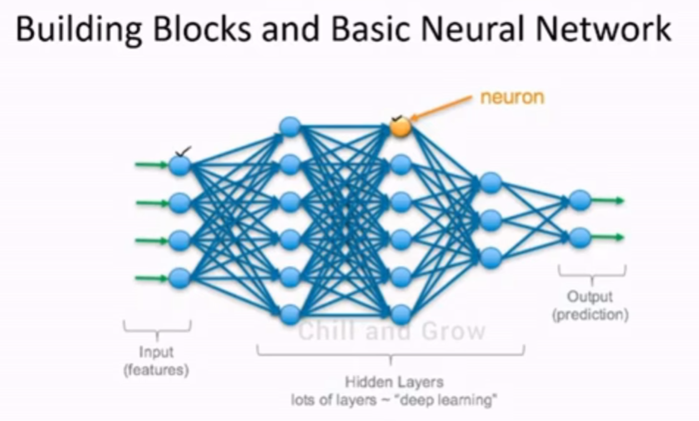
Hidden layers are used to process the inputs which comes from input layer using weights and activation functions.
Bias will be always 1 (there will be a link between each neuron and weights will be assigned over this link
✅ Weights decide importance of each input.
✅ Bias helps adjust the output even if inputs are zero.
Think of a neuron like a recipe:
- Inputs = ingredients (like flour, sugar, eggs)
- Weights = how much of each ingredient you use
- Bias = extra seasoning to make the taste better

How it works:
- Each input (ingredient) is multiplied by its weight (quantity).
- Add them all together.
- Add the bias (extra flavor).
- Pass it through an activation function (like baking the cake).

Example in numbers:
$$\text{Output}=(x_{1}×w_{1})+(x_{2}×w_{2})+⋯+b$$
If:
- $x_{1}=2,w_{1}=3$
- $x_{2}=1,w_{2}=4$
- $b=5$
Then:
$$\text{Output}=(2×3)+(1×4)+5=6+4+5=15$$
1. Weights
- Definition: Weights are numerical values that represent the strength of the connection between neurons in adjacent layers.
- Role: They scale the input features. Each input is multiplied by its corresponding weight before being summed.
- Purpose: Adjusting weights during training allows the network to learn patterns in the data. Larger weights mean the input feature has more influence on the output.
Example:
If you have an input $x$and weight $w$, the contribution to the neuron is $w×x$.

2. Bias
- Definition: Bias is an additional parameter added to the weighted sum of inputs before applying the activation function.
- Role: It allows the activation function to shift left or right, giving the model flexibility to fit the data better.
- Purpose: Without bias, the output would always pass through the origin (0,0), limiting the network’s ability to model complex relationships.
Example:
Neuron output before activation:
$$z=(w_{1}x_{1}+w_{2}x_{2}+⋯+w_{n}x_{n})+b$$

Why Are They Important Together?
- Weights control the slope of the decision boundary.
- Bias shifts the decision boundary. Together, they allow the network to approximate any function (thanks to the Universal Approximation Theorem).
Training neural networks:
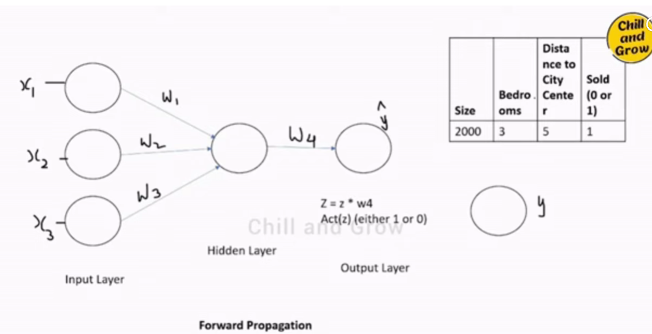

Text: "Summation of product of inputs and weights"
Formula:
- $y=\sum_{i=1}^{n}{}w_{i}x_{i}+b$
• ormula:
$$y=w_{1}x_{1}+w_{2}x_{2}+w_{3}x_{3}+b$$
- Another formula:
$$z=\text{Act}(y)$$
Sigmoid Function:
- Formula:
$$\frac{1}{1+e^{-y}}$$
Sigmoid function returns either 0 or 1
Back propagation:
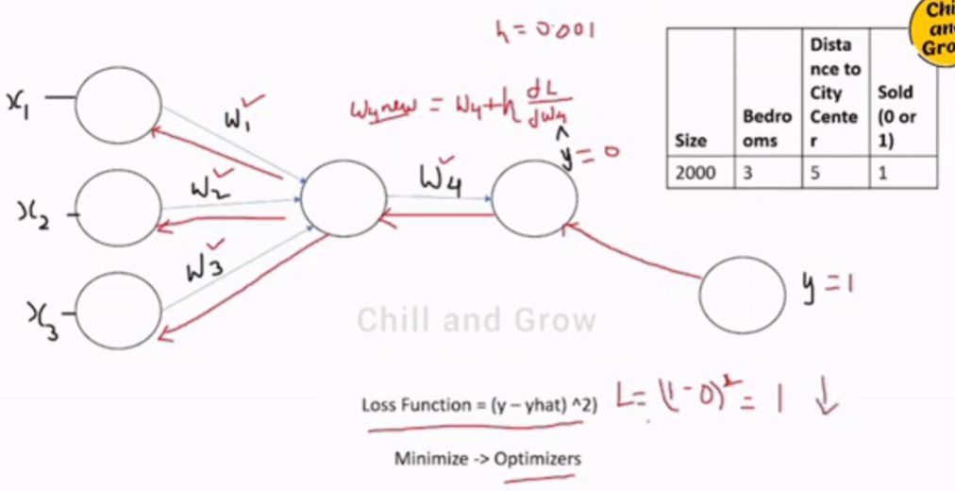
Optimizers are used to minimize the loss.
Activation Functions:
Activation function is a mathematical operation applied to the output of each neuron in the neural network. Its purpose to introduce the non-linearity to the network, allowing it to learn and represent complex pattern in the data. (Whether neuron will be active or off will be decided by activation function)
Sigmoid function: Output will be either 0 or 1
Useful for binary classification.
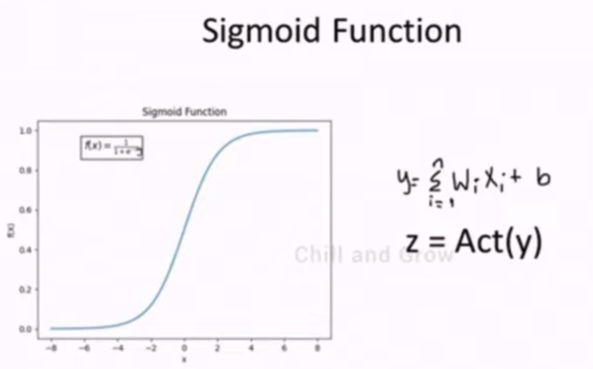
ReLU function: Mostly used in hidden layers.
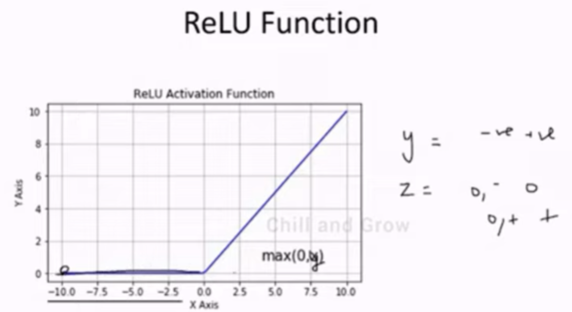
Multilayer neural network -Gradient decent optimizer
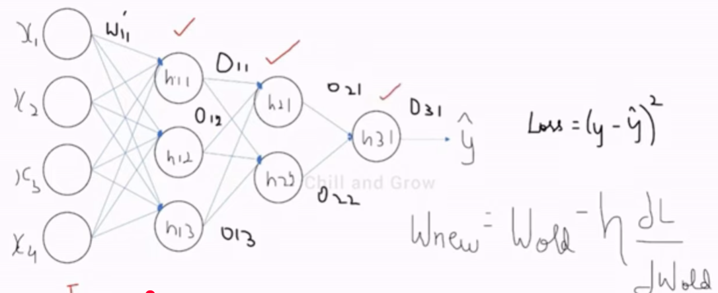
Derivatives are used to find the slope.
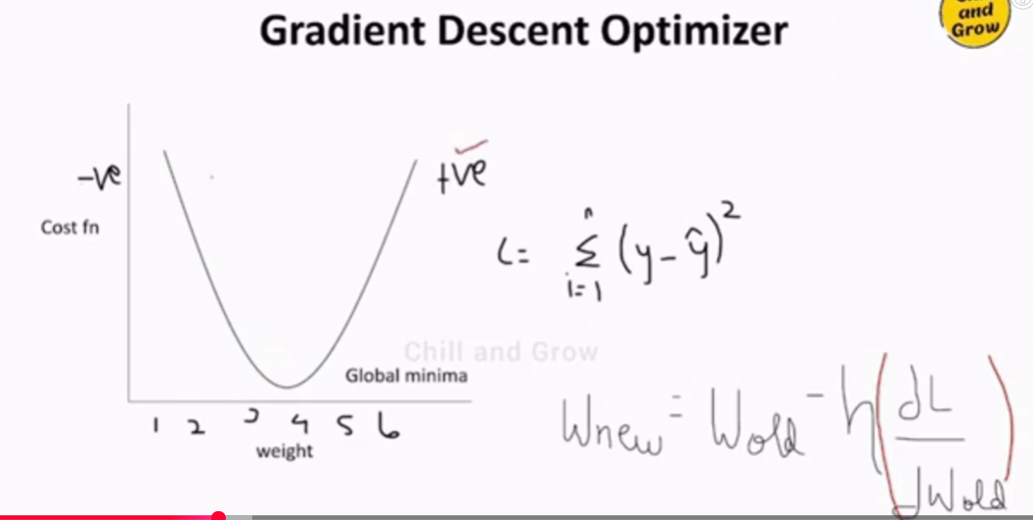
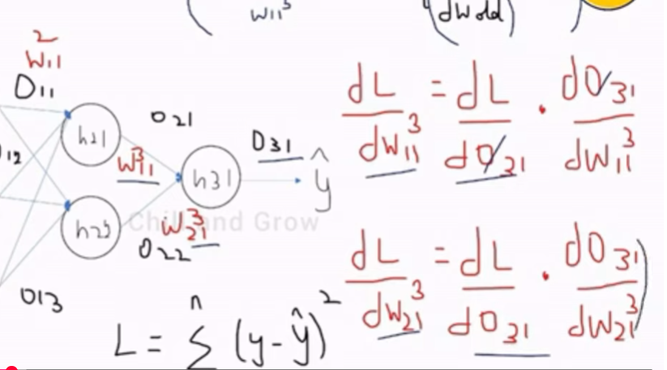
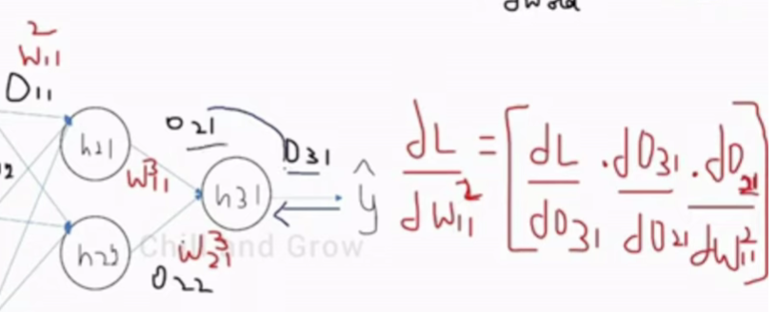

Vanishing gradient problem, exploding gradient problem and weight initialization technique:
🌑 Vanishing Gradient Problem
What is it?
During backpropagation, gradients become extremely small as they move backward through the layers.
Because the gradient is close to zero, earlier layers learn very slowly or stop learning entirely.
Why does it happen?
- Activation functions like sigmoid and tanh squash values into a small range → their derivatives are tiny.
- Multiplying many small numbers across layers → gradient becomes almost zero.
Consequences
- Slow training
- Poor convergence
- Deep models fail to learn long-range dependencies
Example
gradient ≈ 0.1
After 50 layers → 0.1^50 ≈ 1e-50 (almost zero)

🌋 Exploding Gradient Problem
What is it?
Gradients become extremely large during backpropagation, causing instability.
Why does it happen?
- Very deep networks
- Poor weight initialization
- Repeated multiplication of large numbers
Consequences
- Weights grow uncontrollably
- Training becomes unstable
- Loss becomes NaN
- Model diverges
Example
gradient ≈ 5
After 50 layers → 5^50 (huge number, overflows)

🛠 How to Fix These Problems
To fix vanishing gradients
- Use ReLU and its variants (Leaky ReLU, GELU, etc.)
- Use Batch Normalization
- Use Skip connections (ResNet)
- Use better initialization (He/Xavier)
To fix exploding gradients
- Apply Gradient clipping
- Use proper initialization
- Use Batch Norm for stabilization
- Use architectures like LSTM, GRU, or ResNet

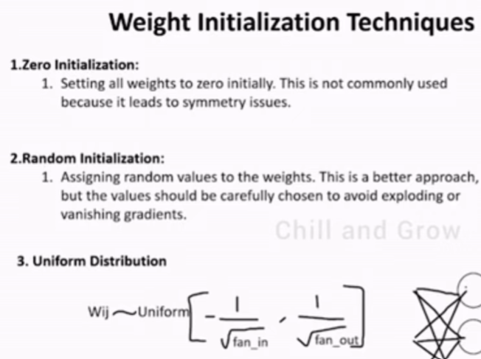
Dropout Layers:
🔍 Why Do We Use Dropout?
If a network becomes too dependent on specific neurons, it overfits—meaning it memorizes training data instead of learning patterns.
By randomly dropping neurons:
- The network becomes more robust
- It learns better general features
- Overfitting reduces significantly
How Dropout Works
During training:
- Dropout rate = p (e.g., 0.2 = drop 20% neurons)
- Random neurons are set to 0 in that layer
- Remaining neurons are scaled up so output distribution stays stable
During inference:
- No neurons are dropped.
- The network uses full capacity for predictions.

ypical Dropout Rates
Scenario | Dropout Rate
Input layer | 0.1 – 0.2
Hidden layers | 0.3 – 0.5
Very deep networks | 0.1 – 0.3
CNNs | Often lower (0.2 – 0.3)
🧩 Where Dropout Is Commonly Used
- Fully connected layers
- LSTMs/GRUs (using recurrent dropout)
- Transformers (attention dropout, embedding dropout)
- CNN classifiers
When NOT to Use Dropout
- Batch Normalization + Dropout can conflict (use carefully)
- Early stages of CNNs
- Small datasets where Dropout may cause underfitting
Ideally drop out ratio should be between 0.2 to 0.5.
Adam Optimizer:
- To reduce the loss, we are using this.
- Stochastic gradient descent + RMSProp
- Direction -> mean , Step -> Variance
Creating Basic ANN:
Keras is a deep learning API written in python and capable of running on top of either JAX, Tensorflow or PyTorch.
From keras.models import sequential
From keras.layers import Dense
From tensorflow.keras.optimizers import Adam
From sklearn.datasets import load_iris
From sklearn.model_selection import train_test_split
From sklearn.preprocessing import StandardScalar
Iris=load_iris()
X=iris.data()
Y=(iris.target==0).astype(int)
X_train,X_test,y_train, y_test=train_test_split(X,Y,test_size=0.2,random_state=0.2)
Scalar=StandardScalar()
#it will learn and transform
X_train=Scalar.fit_transform(X_train)
X_test=Scalar.transform(X_test)
#create a sequential or base model
Model=sequential()
#Add the input layer and 1st hidden layer -> input layer consist of 4 neurons and hidden layer consist of 6 neurons.
Model.add(Dense(units=6, activation=’relu’, input_dim=4)
#Add 2nd hidden layer
Model.add(Dense(units=6, activation=’relu’))
#Add the output layer with sigmoid activation for binary classification
Model.add(Dense(units=1, activation=’sigmoid’))
#Compile the model
Model.compile(optimizer=Adam(learning_rate=0.001), loss=’binary_crossentropy’,metrics=[‘accuracy’])
#display the model summary
Model.summary()
#train the model
Model.fit(X_train, y_train, epochs=10, batch_size=8, validation_split=0.2)
Y_pred=model.predict(x_test)
Y_pred=( Y_pred>0.5)
#Evaluate the model on the test set
Loss, accuracy = model.evaluate(X_test, Y_test)

CNN Algorithm:
Convolutional neural network:
Type of artificial neural network that is particularly good at analysing image / Photo
CNN Architecture:
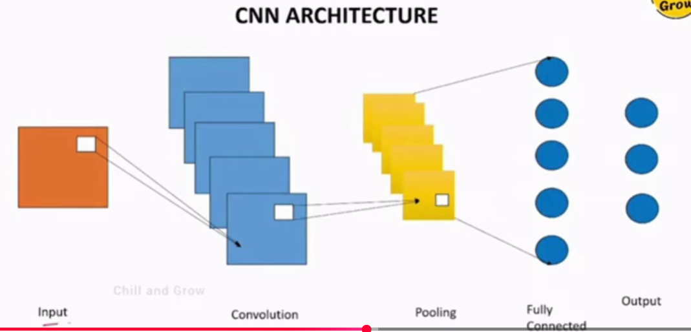
A Convolutional Neural Network (CNN) is a type of deep learning architecture primarily used for image recognition, classification, and computer vision tasks. It is designed to automatically and adaptively learn spatial hierarchies of features from input images.
Here’s a breakdown of the CNN architecture and its layers:

1. Input Layer
- Purpose: Accepts the raw image data.
- Structure: Typically a 3D tensor:
$$\text{Height}×\text{Width}×\text{Channels}$$For example, a 224×224 RGB image → shape: (224, 224, 3).

2. Convolutional Layer
- Purpose: Extracts features from the input image using filters (kernels).
- How it works:
  - A filter (e.g., 3×3 or 5×5) slides over the image.
  - Performs dot product between filter weights and local region of the image.
  - Outputs a feature map.
- Key Parameters:
  - Number of filters: Determines depth of output.
  - Stride: Step size of filter movement.
  - Padding: Maintains spatial dimensions (e.g., “same” or “valid”).
- Intuition: Detects edges, textures, patterns in early layers; complex shapes in deeper layers.

3. Activation Layer (ReLU)
- Purpose: Introduces non-linearity.
- Common function:
$$f(x)=max⁡(0,x)$$This helps the network learn complex patterns instead of just linear relationships.

4. Pooling Layer
- Purpose: Reduces spatial dimensions (downsampling) to make computation efficient and control overfitting.
- Types:
  - Max Pooling: Takes the maximum value in a region.
  - Average Pooling: Takes the average value.
- Example: 2×2 max pooling reduces a 4×4 feature map to 2×2.

5. Fully Connected (Dense) Layer
- Purpose: Combines features learned by convolutional layers to classify the image.
- Structure:
  - Flattens the feature maps into a 1D vector.
  - Passes through dense layers with activation functions (e.g., ReLU, Softmax).
- Softmax: Used in the final layer for multi-class classification.

6. Output Layer
- Purpose: Produces the final prediction.
- Example: For 10 classes, output is a vector of size 10 with probabilities summing to 1.

Typical CNN Flow
Input Image → [Conv → ReLU → Pool] × N → Flatten → Dense → Output

RNN Algorithm:
Class of Artificial neural network where the connection between nodes can create cycles, allowing the output from the previous steps to be used as input for the current step. This structure enables RNNs to maintain a form of memory of previous inputs, making them particularly effective for sequential data tasks like time series prediction, speech recognition, and NLP.
RNN Architecture:
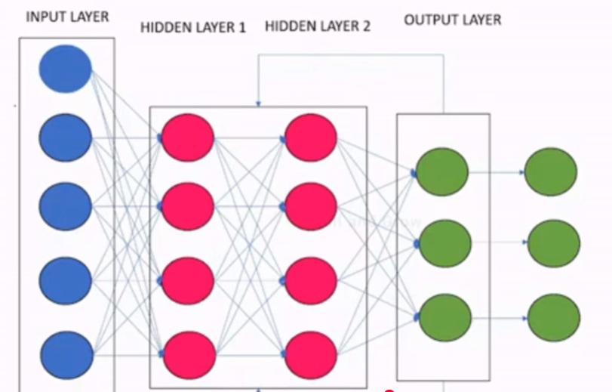
A Recurrent Neural Network (RNN) is a type of neural network designed for sequential data (e.g., text, time series, speech). Unlike CNNs, which work well for spatial data, RNNs handle temporal dependencies by maintaining a hidden state that carries information across time steps.

RNN Architecture Overview
An RNN processes input sequences one element at a time while maintaining a memory of previous inputs through its hidden state.
Key Components
- Input Layer
  - Accepts a sequence of data:
$$X=[x_{1},x_{2},x_{3},…,x_{T}]$$where $T$is the sequence length.
- Hidden Layer (Recurrent Layer)
  - Core of RNN:
$$h_{t}=f(W_{xh}x_{t}+W_{hh}h_{t-1}+b_{h})$$
    - $h_{t}$: hidden state at time $t$
    - $W_{xh}$: weights for input
    - $W_{hh}$: weights for previous hidden state
    - $f$: activation function (usually tanh or ReLU)
  - This recurrence allows the network to remember past information.
- Output Layer
  - Produces output at each time step or after the full sequence:
$$y_{t}=g(W_{hy}h_{t}+b_{y})$$
    - $g$: activation function (e.g., softmax for classification)

Flow of Data
x1 → [RNN Cell] → h1 → y1
x2 → [RNN Cell] → h2 → y2
...
xT → [RNN Cell] → hT → yT
Each cell shares the same weights across time steps.

Variants of RNN
- Vanilla RNN: Basic form, suffers from vanishing/exploding gradients.
- LSTM (Long Short-Term Memory): Adds gates (input, forget, output) to handle long-term dependencies.
- GRU (Gated Recurrent Unit): Simplified version of LSTM with fewer gates.
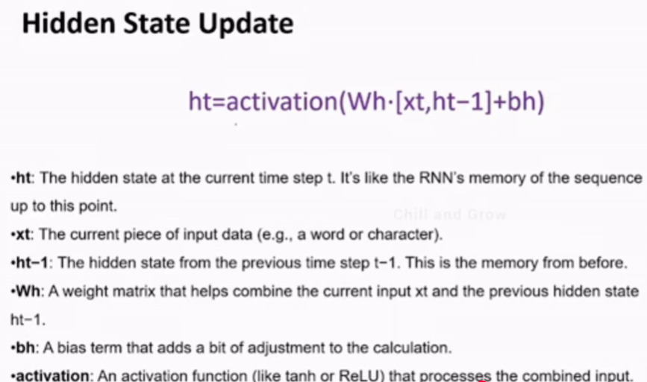
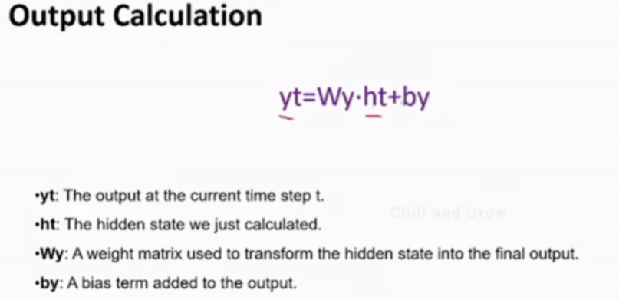
Dec 31st 2025:
NLP in deep learning:
Simple RNN -> LSTM / GRU RNN -> Bidirectional RNN -> Encoder Decoder -> Self Attention -> Transformers
ANN Vs RNN:
Simple RNN:
Forward propagation:
Backward propagation:
Problems with RNN:
When the sentence is getting longer and longer, that time, long term dependency will not be captured by simple RNN.
Key Problems With RNNs
1. Vanishing Gradient Problem
- During backpropagation through many timesteps, gradients become extremely small.
- The network fails to learn long-range dependencies.
- Result: The RNN "forgets" earlier information in long sequences.

2. Exploding Gradients
- Opposite of vanishing gradients — gradients grow very large.
- Causes unstable training and huge weight updates.
- Requires techniques like gradient clipping.

3. Poor Long-Term Memory
- Traditional RNNs struggle to remember information beyond ~10–20 timesteps.
- Not suitable for tasks like long sentences or long-term context tracking.

4. Sequential Processing (No Parallelism)
- RNNs process input one step at a time.
- Cannot use parallel computing efficiently.
- Leads to slow training compared to models like Transformers.

5. Difficult Optimization
- Sensitive to:
  - learning rate
  - sequence length
  - initialization
- Harder to train compared to LSTM, GRU, or Transformer models.

6. Computationally Expensive
- Backpropagation Through Time (BPTT) is heavy.
- Memory usage increases with sequence length.

🟢 Solutions That Overcome RNN Issues
- LSTM (Long Short-Term Memory) → better long-term memory
- GRU (Gated Recurrent Unit) → simpler, faster alternative
- Attention Mechanisms → focus on relevant parts of the input
- Transformers → parallelizable, state-of-the-art for NLP
ANN Project Implementation:
Using Tensorflow, we will be able to create RNN, able to create LSTM RNN.
- TensorFlow is like a big toolbox for machine learning. It has everything you need to build, train, and deploy models — from very basic operations to advanced features.
- Keras is like a friendly helper inside that toolbox. It makes building neural networks easy by giving you simple commands instead of writing lots of complicated code.
Think of it like this:
- TensorFlow = the engine and all the parts.
- Keras = the steering wheel that makes driving easy.
👉 Today, Keras is built into TensorFlow as tf.keras, so you usually use both together.
word2vec — Super Simple Explanation
🚀 What is word2vec?
word2vec is a method that turns words into numbers in such a way that words with similar meanings end up close to each other (in math space).
Think of it like:
- Similar words → sit next to each other
- Different words → stay far apart

🧠 Why do we need it?
Computers don't understand language.
But they understand numbers.
So word2vec converts:
"cat" → [0.24, -1.27, 0.88, …]
"dog" → [0.19, -1.10, 0.80, …]
These numbers capture meaning.

🐶😺 Simple Example
Imagine we have sentences:
- “A cat drinks milk.”
- “A dog drinks water.”
word2vec notices:
- “cat” appears near “drinks”
- “dog” appears near “drinks”
- both are animals
- both behave similarly in sentences
So it learns:
👉 cat and dog are similar words
Their vectors will be close to each other.

WORD2VEC — In-Depth, Intuitive Explanation
word2vec is a neural network model that learns dense vector representations of words such that:
- similar words → similar vectors
- relationships between words → appear as vector arithmetic
It does this by learning from context: the words that surround a target word in real sentences.
1️⃣ Why we need word embeddings
Before word2vec, words were represented as one-hot vectors:
Example: vocabulary size = 10,000
“cat” → 10,000-dimensional vector with a single 1
Problems:
- extremely large
- no meaning (all vectors equally distant)
- cat and dog have zero similarity
word2vec fixes this by learning low-dimensional vectors (50–300 dimensions) that capture meaning.

2️⃣ The Core Idea: “You understand a word by the company it keeps”
This comes from distributional semantics.
Example sentences:
- “The cat sat on the mat”
- “A dog sat on the rug”
cat and dog often appear in similar contexts → therefore, their meaning is similar.
word2vec mathematically captures this intuition.

🌟 The Simplest, Clear, In-Depth Explanation of word2vec
(No math, no jargon — only intuition)

🧠 Think of word2vec as a map of words
Imagine you have a big world map.
- Countries that are close → similar
- Countries far apart → different
word2vec does the same thing, but instead of countries, it places words on a “meaning map”.
Example:
“cat” and “dog” end up close together.
“cat” and “airport” end up far apart.
That’s the entire idea.
Now let’s see how it builds this map.

📌 Step 1: It watches how words appear together
Think of a child listening to thousands of sentences.
From this, the child learns:
- “cat” appears near “milk”, “pet”, “cute”
- “dog” appears near “pet”, “bone”, “bark”
So the child thinks:
👉 “cat” and “dog” must be similar
(because they appear in similar places)
word2vec does EXACTLY this.

📌 Step 2: It assigns each word a “position” (a vector)
At first, the positions (vectors) are random.
But word2vec adjusts the positions every time it sees words together.
Example:
Sentence: “The cat drinks milk.”
word2vec updates positions so:
- “cat” moves closer to “milk”
- also closer to “drinks”
- also closer to “the” (maybe a little)
Sentence: “The dog drinks water.”
Now:
- “dog” moves closer to “drinks”
- “dog” moves closer to “water”
Since both “cat” and “dog” are close to drinks,
they slowly move closer to each other too.
This process happens millions of times while reading text.
Result: 👉 words naturally arrange into patterns of meaning.
End to End deep learning projects with Simple RNN:
Movie Review -> input will be text, and output will be +ve review or -ve review.
Review word2vec tomorrow
:
👉 You want to tune a Random Forest model
Hyperparameters to tune:
- n_estimators (number of trees)
- max_depth (depth of each tree)
We will tune these using:
- Grid Search
- Random Search
- Optuna

🟦 1. Grid Search — Tries ALL combinations
Think of Grid Search like:
👉 “Try all dresses in the shop and choose the best.”
Example:
You choose these hyperparameter options:
Python
n_estimators = [100, 200, 300]
max_depth = [5, 10]
Show more lines
Grid Search will try ALL combinations:
n_estimators | max_depth
100 | 5
100 | 10
200 | 5
200 | 10
300 | 5
300 | 10
Total 3 × 2 = 6 combinations
Even if some combinations are useless, it still tries them.
✔ Simple Summary
- Exhaustive
- Slow
- Good for small parameter sets
- Bad for large search space

🟪 2. Random Search — Tries Random combinations
Think of Random Search like:
👉 “You randomly try a few dresses and hope one looks good.”
Same hyperparameters:
Python
n_estimators = [100, 200, 300]
max_depth = [5, 10]
Show more lines
Instead of trying all 6 combinations, Random Search may try only 3 randomly:
n_estimators | max_depth
200 | 10
100 | 5
300 | 5
It may find a good combination faster.
✔ Simple Summary
- Faster than Grid Search
- Random — might miss the best
- Good when you have many hyperparameters

🟩 3. Optuna — Smart, Automatically Learns
Think of Optuna like:
👉 “A personal stylist learns what colours look good on you and picks better clothes each time.”
Optuna does:
Step 1: Try some random combinations
Step 2: Check score
Step 3: Learn which direction improves score
Step 4: Move towards better values
Step 5: Stop early if trial is bad (pruning)
Example (conceptually)
Optuna tries:
Trial 1 → (n_estimators=300, max_depth=5) → accuracy = 70%
Trial 2 → (n_estimators=250, max_depth=7) → accuracy = 74%
Trial 3 → (n_estimators=260, max_depth=8) → accuracy = 78%
Trial 4 → (n_estimators=270, max_depth=9) → accuracy = 79% (best)
🎯 Optuna figures out:
- Increasing depth gives better results
- Around 260–300 estimators works well
So next trials focus on that zone instead of random guessing.
✔ Simple Summary
- Fastest
- Smart + adaptive
- Stops bad trials early (saves time)
- Best for real-world ML projects

- projects

🎯 FINAL SIMPLE SUMMARY (EASIEST TO SAY IN INTERVIEW)
Grid Search:
Tries all combinations. Slow but thorough.
Random Search:
Tries random combinations. Faster but may miss best.
Optuna:
Tries combinations intelligently, learns from results, and reaches best hyperparameters much faster.
🌟 SUPER EASY REAL-LIFE EXAMPLE
You want to find the best dosa shop in Chennai:
Grid Search = Try all dosa shops
Time-consuming.
Random Search = Try a few random dosa shops
Faster, but may miss the best one.
Optuna = Ask people + taste a few + narrow search + choose best
Smartest and fastest.
.

📘 Example Dataset
Suppose you have the following feature representing customer transaction amounts:
Python
[10, 12, 11, 13, 12, 300, 14, 11, 10, 13]
Show more lines
Here, 300 is clearly an outlier.

✅ 1. Detect Outliers using IQR Method
Step 1: Calculate Q1, Q3 and IQR
Python
import numpy as np
import pandas as pd

data = pd.DataFrame({'amount': [10,12,11,13,12,300,14,11,10,13]})

Q1 = data['amount'].quantile(0.25)
Q3 = data['amount'].quantile(0.75)
IQR = Q3 - Q1

Q1, Q3, IQR
Show more lines
Step 2: Determine outlier boundaries
Python
lower = Q1 - 1.5 * IQR
upper = Q3 + 1.5 * IQR
lower, upper
Show more lines
For this dataset, the upper bound will be much lower than 300 → 300 is detected as an outlier.

✅ 2. Handling Outlier — 3 common ways

A) Remove the Outlier
Python
cleaned = data[(data['amount'] >= lower) & (data['amount'] <= upper)]
cleaned
Show more lines
👉 Result:
10, 12, 11, 13, 12, 14, 11, 10, 13
300 is removed.

B) Cap (Winsorize) the Outlier
Replace values above upper with the upper limit.
Python
data['capped'] = np.clip(data['amount'], lower, upper)
data
Show more lines
👉 Result:
300 becomes upper_bound (≈ 14)

C) Log Transformation (reduce effect of extreme values)
Python
data['log_amount'] = np.log1p(data['amount'])
data
Show more lines
👉 300 becomes log1p(300) ≈ 5.7
Normal values (10–14) become ~2.3–2.7
So the extreme difference gets compressed.

📊 3. Visual Understanding (Boxplot Example)
Python
import matplotlib.pyplot as plt

plt.boxplot(data['amount'])
plt.title("Before Handling Outliers")
plt.show()
``
Show more lines
You would clearly see 300 far above the box.

🧠 Which method is right?
Scenario | Best Technique
Sensor errors | Remove
Skewed data | Log transform
Valid high values (e.g., salary) | Cap
Using linear regression | Treat carefully (remove or transform)
Using tree models | Often ignore

🎉 Summary
Outlier handling involves 3 steps:
- Detect using IQR, Z-Score, or ML-based methods
- Decide based on domain knowledge
- Handle using removal, capping, or transformation

